 | UNIQUE CENTRAL SCHOOL  KNOWLEDGE ★ CHARACTER ★ PROGRESS  ACADEMIC SESSION : 2026 – 2027  RESULT / MARKSHEET  (P.T.1 – 40 | P.T..2 – 40 | S.A.-1 – 80 | Total – 100) | 

Class : II | Section : A | Roll No. : 01

Student Information  Student Name : Riya Kumari  Father’s Name : Mr. Birendra Sah  Mother’s Name : Mrs. Rinki Devi | PHOTO  (Optional) | Result Summary
  Total Marks : | 592 / 800
  Percentage (%) : | 74.00 %
  Overall Grade : | B1
  Result : | PASS
  Rank : | 1

S.No. | Subject | Internal Assessment |  |  |  | Summative  Assessment I  (80 marks) | Total  (100 marks) | Grade
S.No. | Subject | P.T. I | P.T. II | Multiple Assessment | Subject Enrichment | Summative  Assessment I  (80 marks) | Total  (100 marks) | Grade
S.No. | Subject | (5 marks) | (5 marks) | (5 marks) | (5 marks) | Summative  Assessment I  (80 marks) | Total  (100 marks) | Grade
1 | Hindi | 5 | 3 | 5 | 5 | 34 | 52 | C1
2 | English | 4 | 4 | 5 | 5 | 67 | 85 | A2
3 | Maths | 3 | 3 | 5 | 5 | 76 | 92 | A1
4 | Science | 1 | 1 | 5 | 5 | 55 | 67 | B2
5 | Social Sc. | 3 | 5 | 5 | 5 | 32 | 50 | C2
6 | Sans. / Urdu | 3 | 4 | 5 | 5 | 55 | 72 | B1
7 | G.K. | 3 | 2 | 5 | 5 | 66 | 81 | A2
8 | Computer | 4 | 4 | 5 | 5 | 75 | 93 | A1

CO-SCHOLASTIC AREAS |  |  |  |  |  |  | SCALE
Subject | Drawing | Music | Uniform | Sports | Discipline |  | GRADE | A1 | A2 | B1 | B2 | C1 | C2 | D | E
Grade | B | B | A | A | A |  | MARKS RANGE | 91-100 | 81-90 | 71-80 | 61-70 | 51-60 | 41-50 | 31-40 | Below 30
 |  |  |  |  |  |  | CO-SCH. AREAS | GRADE A  Outstanding |  | GRADE B  Very Good |  | GRADE C  Fair

Attendance  Working Days : 132  Present : 128  Absent : 4 | Teacher’s Remark  Very good performance by Riya. Regular revision will make it  even better. |  | Performance Chart (Total /100 : Student vs Class Average)  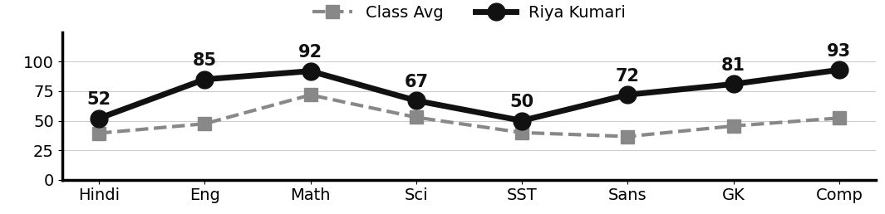
  Class Teacher |  | —— Better Education ★ Brighter Future —— |  | 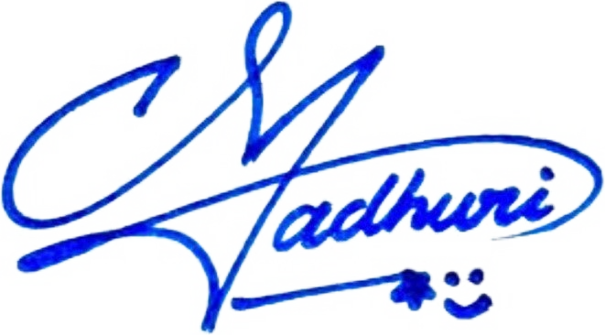  Principal

UNIQUE CENTRAL SCHOOL
KNOWLEDGE ★ CHARACTER ★ PROGRESS
ACADEMIC SESSION : 2026 – 2027
RESULT / MARKSHEET
(P.T.1 – 40 | P.T..2 – 40 | S.A.-1 – 80 | Total – 100)

Class : II | Section : A | Roll No. : 02

Student Information  Student Name : Nadra Praveen  Father’s Name : Mr. Shafi Alam  Mother’s Name : Mrs. Raisha Khatoon | PHOTO  (Optional) | Result Summary
  Total Marks : | 507 / 800
  Percentage (%) : | 63.38 %
  Overall Grade : | B2
  Result : | PASS
  Rank : | 5

S.No. | Subject | Internal Assessment |  |  |  | Summative  Assessment I  (80 marks) | Total  (100 marks) | Grade
S.No. | Subject | P.T. I | P.T. II | Multiple Assessment | Subject Enrichment | Summative  Assessment I  (80 marks) | Total  (100 marks) | Grade
S.No. | Subject | (5 marks) | (5 marks) | (5 marks) | (5 marks) | Summative  Assessment I  (80 marks) | Total  (100 marks) | Grade
1 | Hindi | 4 | 2 | 5 | 5 | 40 | 56 | C1
2 | English | 4 | 4 | 5 | 5 | 51 | 69 | B2
3 | Maths | 0 | 4 | 5 | 5 | 73 | 87 | A2
4 | Science | 1 | 1 | 5 | 5 | 60 | 72 | B1
5 | Social Sc. | 0 | 3 | 5 | 5 | 51 | 64 | B2
6 | Sans. / Urdu | 0 | 2 | 5 | 5 | 31 | 43 | C2
7 | G.K. | 3 | 2 | 5 | 5 | 40 | 55 | C1
8 | Computer | 5 | 3 | 5 | 5 | 43 | 61 | B2

CO-SCHOLASTIC AREAS |  |  |  |  |  |  | SCALE
Subject | Drawing | Music | Uniform | Sports | Discipline |  | GRADE | A1 | A2 | B1 | B2 | C1 | C2 | D | E
Grade | B | C | A | B | A |  | MARKS RANGE | 91-100 | 81-90 | 71-80 | 61-70 | 51-60 | 41-50 | 31-40 | Below 30
 |  |  |  |  |  |  | CO-SCH. AREAS | GRADE A  Outstanding |  | GRADE B  Very Good |  | GRADE C  Fair

Attendance  Working Days : 132  Present : 122  Absent : 10 | Teacher’s Remark  Good effort by Nadra. Needs regular practice to reach a  higher level. Give more time to Sanskrit/Urdu. |  | Performance Chart (Total /100 : Student vs Class Average)  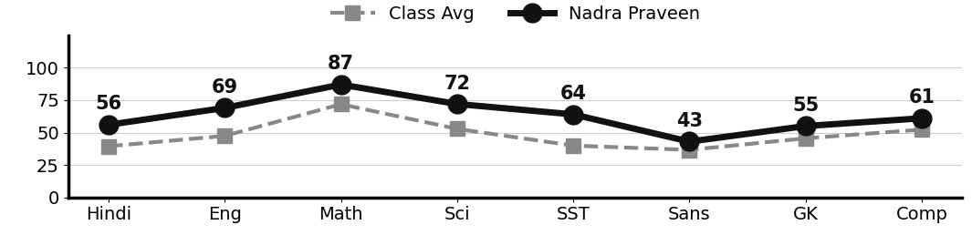
Class Teacher |  | —— Better Education ★ Brighter Future —— |  | Principal

UNIQUE CENTRAL SCHOOL
KNOWLEDGE ★ CHARACTER ★ PROGRESS
ACADEMIC SESSION : 2026 – 2027
RESULT / MARKSHEET
(P.T.1 – 40 | P.T..2 – 40 | S.A.-1 – 80 | Total – 100)

Class : II | Section : A | Roll No. : 03

Student Information  Student Name : Rishi Kumar  Father’s Name : Mr. Ravi Prasad  Mother’s Name : Mrs. Dimpal Devi | PHOTO  (Optional) | Result Summary
  Total Marks : | 520 / 800
  Percentage (%) : | 65.00 %
  Overall Grade : | B2
  Result : | PASS
  Rank : | 4

S.No. | Subject | Internal Assessment |  |  |  | Summative  Assessment I  (80 marks) | Total  (100 marks) | Grade
S.No. | Subject | P.T. I | P.T. II | Multiple Assessment | Subject Enrichment | Summative  Assessment I  (80 marks) | Total  (100 marks) | Grade
S.No. | Subject | (5 marks) | (5 marks) | (5 marks) | (5 marks) | Summative  Assessment I  (80 marks) | Total  (100 marks) | Grade
1 | Hindi | 0 | 0 | 5 | 5 | 45 | 55 | C1
2 | English | 0 | 0 | 5 | 5 | 86 | 96 | A1
3 | Maths | 2 | 4 | 5 | 5 | 56 | 72 | B1
4 | Science | 1 | 3 | 5 | 5 | 42 | 56 | C1
5 | Social Sc. | 2 | 3 | 5 | 5 | 36 | 51 | C1
6 | Sans. / Urdu | 2 | 2 | 5 | 5 | 32 | 46 | C2
7 | G.K. | 0 | 0 | 5 | 5 | 50 | 60 | C1
8 | Computer | 0 | 0 | 5 | 5 | 74 | 84 | A2

CO-SCHOLASTIC AREAS |  |  |  |  |  |  | SCALE
Subject | Drawing | Music | Uniform | Sports | Discipline |  | GRADE | A1 | A2 | B1 | B2 | C1 | C2 | D | E
Grade | B | B | A | B | A |  | MARKS RANGE | 91-100 | 81-90 | 71-80 | 61-70 | 51-60 | 41-50 | 31-40 | Below 30
 |  |  |  |  |  |  | CO-SCH. AREAS | GRADE A  Outstanding |  | GRADE B  Very Good |  | GRADE C  Fair

Attendance  Working Days : 132  Present : 129  Absent : 3 | Teacher’s Remark  Rishi has shown good progress. Regular practice and revision  will give better results. Give more time to Sanskrit/Urdu. |  | Performance Chart (Total /100 : Student vs Class Average)  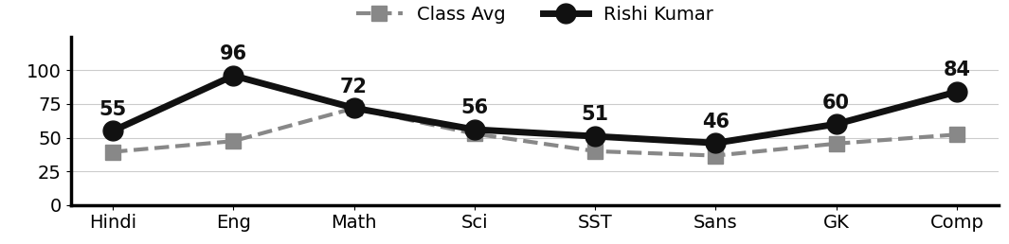
Class Teacher |  | —— Better Education ★ Brighter Future —— |  | Principal

UNIQUE CENTRAL SCHOOL
KNOWLEDGE ★ CHARACTER ★ PROGRESS
ACADEMIC SESSION : 2026 – 2027
RESULT / MARKSHEET
(P.T.1 – 40 | P.T..2 – 40 | S.A.-1 – 80 | Total – 100)

Class : II | Section : A | Roll No. : 04

Student Information  Student Name : Rupam Kumari  Father’s Name : Mr. Ninash Kumar  Mother’s Name : Mrs. Mamta Devi | PHOTO  (Optional) | Result Summary
  Total Marks : | 568 / 800
  Percentage (%) : | 71.00 %
  Overall Grade : | B1
  Result : | PASS
  Rank : | 2

S.No. | Subject | Internal Assessment |  |  |  | Summative  Assessment I  (80 marks) | Total  (100 marks) | Grade
S.No. | Subject | P.T. I | P.T. II | Multiple Assessment | Subject Enrichment | Summative  Assessment I  (80 marks) | Total  (100 marks) | Grade
S.No. | Subject | (5 marks) | (5 marks) | (5 marks) | (5 marks) | Summative  Assessment I  (80 marks) | Total  (100 marks) | Grade
1 | Hindi | 4 | 3 | 5 | 5 | 47 | 64 | B2
2 | English | 2 | 4 | 5 | 5 | 59 | 75 | B1
3 | Maths | 5 | 4 | 5 | 5 | 76 | 95 | A1
4 | Science | 0 | 1 | 5 | 5 | 60 | 71 | B1
5 | Social Sc. | 4 | 2 | 5 | 5 | 41 | 57 | C1
6 | Sans. / Urdu | 2 | 4 | 5 | 5 | 61 | 77 | B1
7 | G.K. | 2 | 3 | 5 | 5 | 52 | 67 | B2
8 | Computer | 3 | 4 | 5 | 5 | 45 | 62 | B2

CO-SCHOLASTIC AREAS |  |  |  |  |  |  | SCALE
Subject | Drawing | Music | Uniform | Sports | Discipline |  | GRADE | A1 | A2 | B1 | B2 | C1 | C2 | D | E
Grade | A | B | A | B | A |  | MARKS RANGE | 91-100 | 81-90 | 71-80 | 61-70 | 51-60 | 41-50 | 31-40 | Below 30
 |  |  |  |  |  |  | CO-SCH. AREAS | GRADE A  Outstanding |  | GRADE B  Very Good |  | GRADE C  Fair

Attendance  Working Days : 132  Present : 126  Absent : 6 | Teacher’s Remark  Rupam has performed very well and shows good understanding. A  little more practice will bring top results. |  | Performance Chart (Total /100 : Student vs Class Average)  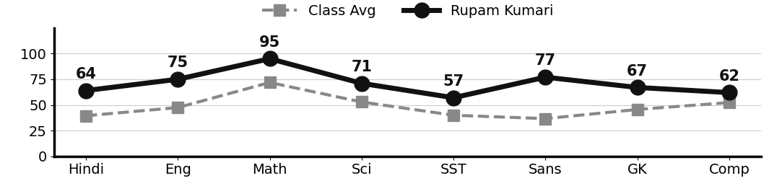
Class Teacher |  | —— Better Education ★ Brighter Future —— |  | Principal

UNIQUE CENTRAL SCHOOL
KNOWLEDGE ★ CHARACTER ★ PROGRESS
ACADEMIC SESSION : 2026 – 2027
RESULT / MARKSHEET
(P.T.1 – 40 | P.T..2 – 40 | S.A.-1 – 80 | Total – 100)

Class : II | Section : A | Roll No. : 05

Student Information  Student Name : Dipanshu Kumar  Father’s Name : Mr. Sarvesh Kumar  Mother’s Name : Mrs. Nitu Devi | PHOTO  (Optional) | Result Summary
  Total Marks : | 400 / 800
  Percentage (%) : | 50.00 %
  Overall Grade : | C2
  Result : | PASS
  Rank : | 11

S.No. | Subject | Internal Assessment |  |  |  | Summative  Assessment I  (80 marks) | Total  (100 marks) | Grade
S.No. | Subject | P.T. I | P.T. II | Multiple Assessment | Subject Enrichment | Summative  Assessment I  (80 marks) | Total  (100 marks) | Grade
S.No. | Subject | (5 marks) | (5 marks) | (5 marks) | (5 marks) | Summative  Assessment I  (80 marks) | Total  (100 marks) | Grade
1 | Hindi | 0 | 0 | 4 | 4 | 34 | 42 | C2
2 | English | 2 | 0 | 4 | 4 | 29 | 39 | D
3 | Maths | 2 | 0 | 4 | 4 | 42 | 52 | C1
4 | Science | 1 | 0 | 4 | 4 | 54 | 63 | B2
5 | Social Sc. | 3 | 1 | 4 | 4 | 45 | 57 | C1
6 | Sans. / Urdu | 1 | 3 | 4 | 4 | 35 | 47 | C2
7 | G.K. | 2 | 0 | 4 | 4 | 40 | 50 | C2
8 | Computer | 0 | 0 | 4 | 4 | 42 | 50 | C2

CO-SCHOLASTIC AREAS |  |  |  |  |  |  | SCALE
Subject | Drawing | Music | Uniform | Sports | Discipline |  | GRADE | A1 | A2 | B1 | B2 | C1 | C2 | D | E
Grade | C | C | A | C | B |  | MARKS RANGE | 91-100 | 81-90 | 71-80 | 61-70 | 51-60 | 41-50 | 31-40 | Below 30
 |  |  |  |  |  |  | CO-SCH. AREAS | GRADE A  Outstanding |  | GRADE B  Very Good |  | GRADE C  Fair

Attendance  Working Days : 132  Present : 118  Absent : 14 | Teacher’s Remark  Dipanshu is making steady effort but needs more practice and  regular revision. Give more time to English. |  | Performance Chart (Total /100 : Student vs Class Average)  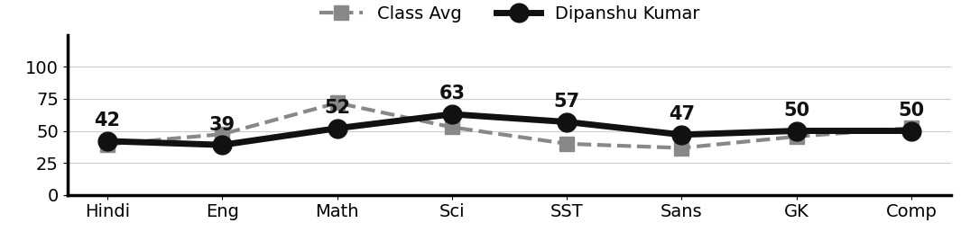
Class Teacher |  | —— Better Education ★ Brighter Future —— |  | Principal

UNIQUE CENTRAL SCHOOL
KNOWLEDGE ★ CHARACTER ★ PROGRESS
ACADEMIC SESSION : 2026 – 2027
RESULT / MARKSHEET
(P.T.1 – 40 | P.T..2 – 40 | S.A.-1 – 80 | Total – 100)

Class : II | Section : A | Roll No. : 06

Student Information  Student Name : Sona Kumari  Father’s Name : Mr. Ravindra Kumar  Mother’s Name : Mrs. Priyanka Kumari | PHOTO  (Optional) | Result Summary
  Total Marks : | 344 / 800
  Percentage (%) : | 43.00 %
  Overall Grade : | C2
  Result : | PASS
  Rank : | 21

S.No. | Subject | Internal Assessment |  |  |  | Summative  Assessment I  (80 marks) | Total  (100 marks) | Grade
S.No. | Subject | P.T. I | P.T. II | Multiple Assessment | Subject Enrichment | Summative  Assessment I  (80 marks) | Total  (100 marks) | Grade
S.No. | Subject | (5 marks) | (5 marks) | (5 marks) | (5 marks) | Summative  Assessment I  (80 marks) | Total  (100 marks) | Grade
1 | Hindi | 2 | 2 | 4 | 4 | 18 | 30 | E
2 | English | 1 | 3 | 4 | 4 | 35 | 47 | C2
3 | Maths | 1 | 4 | 4 | 4 | 41 | 54 | C1
4 | Science | 1 | 2 | 4 | 4 | 50 | 61 | B2
5 | Social Sc. | 1 | 4 | 4 | 4 | 23 | 36 | D
6 | Sans. / Urdu | 2 | 2 | 4 | 4 | 5 | 17 | E
7 | G.K. | 4 | 2 | 4 | 4 | 28 | 42 | C2
8 | Computer | 3 | 4 | 4 | 4 | 42 | 57 | C1

CO-SCHOLASTIC AREAS |  |  |  |  |  |  | SCALE
Subject | Drawing | Music | Uniform | Sports | Discipline |  | GRADE | A1 | A2 | B1 | B2 | C1 | C2 | D | E
Grade | C | C | A | C | A |  | MARKS RANGE | 91-100 | 81-90 | 71-80 | 61-70 | 51-60 | 41-50 | 31-40 | Below 30
 |  |  |  |  |  |  | CO-SCH. AREAS | GRADE A  Outstanding |  | GRADE B  Very Good |  | GRADE C  Fair

Attendance  Working Days : 132  Present : 122  Absent : 10 | Teacher’s Remark  Sona has the ability to improve with regular study and hard  work. Give more time to Sanskrit/Urdu. |  | Performance Chart (Total /100 : Student vs Class Average)  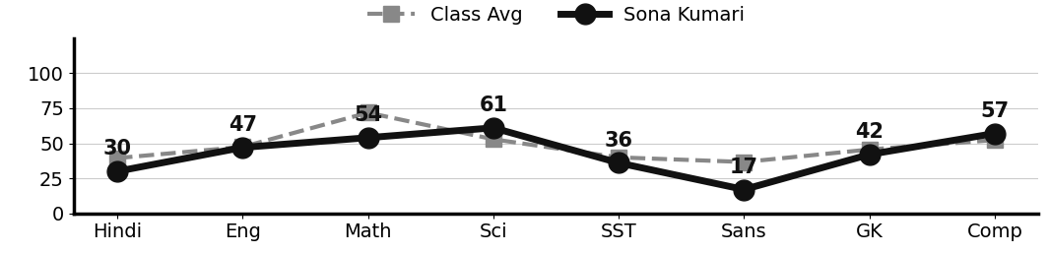
Class Teacher |  | —— Better Education ★ Brighter Future —— |  | Principal

UNIQUE CENTRAL SCHOOL
KNOWLEDGE ★ CHARACTER ★ PROGRESS
ACADEMIC SESSION : 2026 – 2027
RESULT / MARKSHEET
(P.T.1 – 40 | P.T..2 – 40 | S.A.-1 – 80 | Total – 100)

Class : II | Section : A | Roll No. : 07

Student Information  Student Name : Anupriya Kumari  Father’s Name : Mr. Sarvesh Kumar  Mother’s Name : Mrs. Guddi Devi | PHOTO  (Optional) | Result Summary
  Total Marks : | 373 / 800
  Percentage (%) : | 46.62 %
  Overall Grade : | C2
  Result : | PASS
  Rank : | 16

S.No. | Subject | Internal Assessment |  |  |  | Summative  Assessment I  (80 marks) | Total  (100 marks) | Grade
S.No. | Subject | P.T. I | P.T. II | Multiple Assessment | Subject Enrichment | Summative  Assessment I  (80 marks) | Total  (100 marks) | Grade
S.No. | Subject | (5 marks) | (5 marks) | (5 marks) | (5 marks) | Summative  Assessment I  (80 marks) | Total  (100 marks) | Grade
1 | Hindi | 4 | 3 | 4 | 4 | 31 | 46 | C2
2 | English | 4 | 4 | 4 | 4 | 31 | 47 | C2
3 | Maths | 2 | 4 | 4 | 4 | 48 | 62 | B2
4 | Science | 1 | 4 | 4 | 4 | 40 | 53 | C1
5 | Social Sc. | 2 | 3 | 4 | 4 | 38 | 51 | C1
6 | Sans. / Urdu | 2 | 2 | 4 | 4 | 10 | 22 | E
7 | G.K. | 3 | 3 | 4 | 4 | 34 | 48 | C2
8 | Computer | 3 | 3 | 4 | 4 | 30 | 44 | C2

CO-SCHOLASTIC AREAS |  |  |  |  |  |  | SCALE
Subject | Drawing | Music | Uniform | Sports | Discipline |  | GRADE | A1 | A2 | B1 | B2 | C1 | C2 | D | E
Grade | C | C | A | C | A |  | MARKS RANGE | 91-100 | 81-90 | 71-80 | 61-70 | 51-60 | 41-50 | 31-40 | Below 30
 |  |  |  |  |  |  | CO-SCH. AREAS | GRADE A  Outstanding |  | GRADE B  Very Good |  | GRADE C  Fair

Attendance  Working Days : 132  Present : 125  Absent : 7 | Teacher’s Remark  Anupriya can do better with more attention and daily  practice. Give more time to Sanskrit/Urdu. |  | Performance Chart (Total /100 : Student vs Class Average)  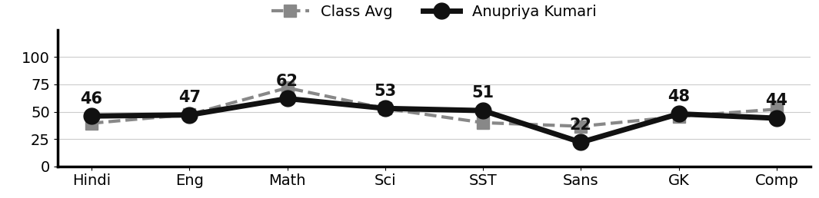
Class Teacher |  | —— Better Education ★ Brighter Future —— |  | Principal

UNIQUE CENTRAL SCHOOL
KNOWLEDGE ★ CHARACTER ★ PROGRESS
ACADEMIC SESSION : 2026 – 2027
RESULT / MARKSHEET
(P.T.1 – 40 | P.T..2 – 40 | S.A.-1 – 80 | Total – 100)

Class : II | Section : A | Roll No. : 08

Student Information  Student Name : Rishi Kumar  Father’s Name : Mr. Prabhu Kumar  Mother’s Name : Mrs. Pushpa Bharti | PHOTO  (Optional) | Result Summary
  Total Marks : | 496 / 800
  Percentage (%) : | 62.00 %
  Overall Grade : | B2
  Result : | PASS
  Rank : | 6

S.No. | Subject | Internal Assessment |  |  |  | Summative  Assessment I  (80 marks) | Total  (100 marks) | Grade
S.No. | Subject | P.T. I | P.T. II | Multiple Assessment | Subject Enrichment | Summative  Assessment I  (80 marks) | Total  (100 marks) | Grade
S.No. | Subject | (5 marks) | (5 marks) | (5 marks) | (5 marks) | Summative  Assessment I  (80 marks) | Total  (100 marks) | Grade
1 | Hindi | 4 | 5 | 5 | 5 | 38 | 57 | C1
2 | English | 3 | 3 | 5 | 5 | 22 | 38 | D
3 | Maths | 4 | 5 | 5 | 5 | 65 | 84 | A2
4 | Science | 3 | 4 | 5 | 5 | 75 | 92 | A1
5 | Social Sc. | 2 | 2 | 5 | 5 | 28 | 42 | C2
6 | Sans. / Urdu | 3 | 4 | 5 | 5 | 48 | 65 | B2
7 | G.K. | 2 | 2 | 5 | 5 | 52 | 66 | B2
8 | Computer | 4 | 2 | 5 | 5 | 36 | 52 | C1

CO-SCHOLASTIC AREAS |  |  |  |  |  |  | SCALE
Subject | Drawing | Music | Uniform | Sports | Discipline |  | GRADE | A1 | A2 | B1 | B2 | C1 | C2 | D | E
Grade | A | C | A | B | A |  | MARKS RANGE | 91-100 | 81-90 | 71-80 | 61-70 | 51-60 | 41-50 | 31-40 | Below 30
 |  |  |  |  |  |  | CO-SCH. AREAS | GRADE A  Outstanding |  | GRADE B  Very Good |  | GRADE C  Fair

Attendance  Working Days : 132  Present : 123  Absent : 9 | Teacher’s Remark  Good effort by Rishi. Needs regular practice to reach a  higher level. Give more time to English. |  | Performance Chart (Total /100 : Student vs Class Average)  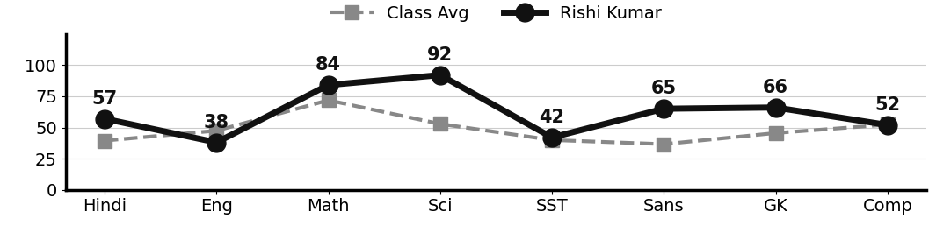
Class Teacher |  | —— Better Education ★ Brighter Future —— |  | Principal

UNIQUE CENTRAL SCHOOL
KNOWLEDGE ★ CHARACTER ★ PROGRESS
ACADEMIC SESSION : 2026 – 2027
RESULT / MARKSHEET
(P.T.1 – 40 | P.T..2 – 40 | S.A.-1 – 80 | Total – 100)

Class : II | Section : A | Roll No. : 09

Student Information  Student Name : Rikki Kumari  Father’s Name : Mr. Ranjeet Kumar  Mother’s Name : Mrs. Rani Kumari | PHOTO  (Optional) | Result Summary
  Total Marks : | 415 / 800
  Percentage (%) : | 51.88 %
  Overall Grade : | C1
  Result : | PASS
  Rank : | 9

S.No. | Subject | Internal Assessment |  |  |  | Summative  Assessment I  (80 marks) | Total  (100 marks) | Grade
S.No. | Subject | P.T. I | P.T. II | Multiple Assessment | Subject Enrichment | Summative  Assessment I  (80 marks) | Total  (100 marks) | Grade
S.No. | Subject | (5 marks) | (5 marks) | (5 marks) | (5 marks) | Summative  Assessment I  (80 marks) | Total  (100 marks) | Grade
1 | Hindi | 4 | 1 | 4 | 4 | 20 | 33 | D
2 | English | 3 | 4 | 4 | 4 | 27 | 42 | C2
3 | Maths | 4 | 4 | 4 | 4 | 68 | 84 | A2
4 | Science | 1 | 4 | 4 | 4 | 47 | 60 | C1
5 | Social Sc. | 3 | 3 | 4 | 4 | 33 | 47 | C2
6 | Sans. / Urdu | 1 | 3 | 4 | 4 | 25 | 37 | D
7 | G.K. | 2 | 4 | 4 | 4 | 44 | 58 | C1
8 | Computer | 2 | 2 | 4 | 4 | 42 | 54 | C1

CO-SCHOLASTIC AREAS |  |  |  |  |  |  | SCALE
Subject | Drawing | Music | Uniform | Sports | Discipline |  | GRADE | A1 | A2 | B1 | B2 | C1 | C2 | D | E
Grade | B | C | A | B | B |  | MARKS RANGE | 91-100 | 81-90 | 71-80 | 61-70 | 51-60 | 41-50 | 31-40 | Below 30
 |  |  |  |  |  |  | CO-SCH. AREAS | GRADE A  Outstanding |  | GRADE B  Very Good |  | GRADE C  Fair

Attendance  Working Days : 132  Present : 115  Absent : 17 | Teacher’s Remark  Rikki is sincere and doing well. More effort will bring  further improvement. Give more time to Hindi. |  | Performance Chart (Total /100 : Student vs Class Average)  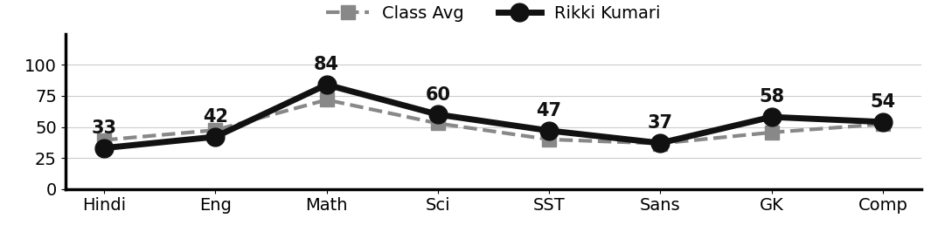
Class Teacher |  | —— Better Education ★ Brighter Future —— |  | Principal

UNIQUE CENTRAL SCHOOL
KNOWLEDGE ★ CHARACTER ★ PROGRESS
ACADEMIC SESSION : 2026 – 2027
RESULT / MARKSHEET
(P.T.1 – 40 | P.T..2 – 40 | S.A.-1 – 80 | Total – 100)

Class : II | Section : A | Roll No. : 10

Student Information  Student Name : Khushi Praveen  Father’s Name : Mr. Md. Munna  Mother’s Name : Mrs. Chanda Praveen | PHOTO  (Optional) | Result Summary
  Total Marks : | 381 / 800
  Percentage (%) : | 47.62 %
  Overall Grade : | C2
  Result : | PASS
  Rank : | 13

S.No. | Subject | Internal Assessment |  |  |  | Summative  Assessment I  (80 marks) | Total  (100 marks) | Grade
S.No. | Subject | P.T. I | P.T. II | Multiple Assessment | Subject Enrichment | Summative  Assessment I  (80 marks) | Total  (100 marks) | Grade
S.No. | Subject | (5 marks) | (5 marks) | (5 marks) | (5 marks) | Summative  Assessment I  (80 marks) | Total  (100 marks) | Grade
1 | Hindi | 0 | 2 | 4 | 4 | 26 | 36 | D
2 | English | 0 | 4 | 4 | 4 | 18 | 30 | E
3 | Maths | 3 | 4 | 4 | 4 | 72 | 87 | A2
4 | Science | 3 | 1 | 4 | 4 | 53 | 65 | B2
5 | Social Sc. | 2 | 4 | 4 | 4 | 18 | 32 | D
6 | Sans. / Urdu | 2 | 2 | 4 | 4 | 19 | 31 | D
7 | G.K. | 0 | 3 | 4 | 4 | 44 | 55 | C1
8 | Computer | 0 | 4 | 4 | 4 | 33 | 45 | C2

CO-SCHOLASTIC AREAS |  |  |  |  |  |  | SCALE
Subject | Drawing | Music | Uniform | Sports | Discipline |  | GRADE | A1 | A2 | B1 | B2 | C1 | C2 | D | E
Grade | B | C | B | B | B |  | MARKS RANGE | 91-100 | 81-90 | 71-80 | 61-70 | 51-60 | 41-50 | 31-40 | Below 30
 |  |  |  |  |  |  | CO-SCH. AREAS | GRADE A  Outstanding |  | GRADE B  Very Good |  | GRADE C  Fair

Attendance  Working Days : 132  Present : 105  Absent : 27 | Teacher’s Remark  Khushi can do better with more attention and daily practice.  Give more time to English. |  | Performance Chart (Total /100 : Student vs Class Average)  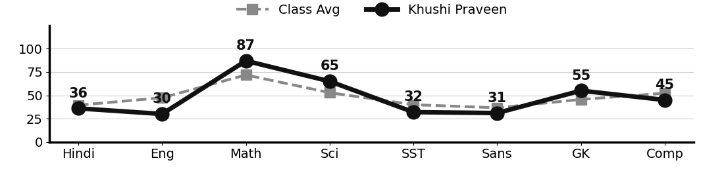
Class Teacher |  | —— Better Education ★ Brighter Future —— |  | Principal

UNIQUE CENTRAL SCHOOL
KNOWLEDGE ★ CHARACTER ★ PROGRESS
ACADEMIC SESSION : 2026 – 2027
RESULT / MARKSHEET
(P.T.1 – 40 | P.T..2 – 40 | S.A.-1 – 80 | Total – 100)

Class : II | Section : A | Roll No. : 11

Student Information  Student Name : Nancy Kumari  Father’s Name : Mr. Suraj Kumar  Mother’s Name : Mrs. Neha Kumari | PHOTO  (Optional) | Result Summary
  Total Marks : | 326 / 800
  Percentage (%) : | 40.75 %
  Overall Grade : | D
  Result : | PASS
  Rank : | 25

S.No. | Subject | Internal Assessment |  |  |  | Summative  Assessment I  (80 marks) | Total  (100 marks) | Grade
S.No. | Subject | P.T. I | P.T. II | Multiple Assessment | Subject Enrichment | Summative  Assessment I  (80 marks) | Total  (100 marks) | Grade
S.No. | Subject | (5 marks) | (5 marks) | (5 marks) | (5 marks) | Summative  Assessment I  (80 marks) | Total  (100 marks) | Grade
1 | Hindi | 0 | 2 | 4 | 4 | 20 | 30 | E
2 | English | 0 | 3 | 4 | 4 | 32 | 43 | C2
3 | Maths | 3 | 4 | 4 | 4 | 66 | 81 | A2
4 | Science | 3 | 2 | 4 | 4 | 20 | 33 | D
5 | Social Sc. | 2 | 3 | 4 | 4 | 14 | 27 | E
6 | Sans. / Urdu | 2 | 2 | 4 | 4 | 8 | 20 | E
7 | G.K. | 0 | 2 | 4 | 4 | 26 | 36 | D
8 | Computer | 0 | 4 | 4 | 4 | 44 | 56 | C1

CO-SCHOLASTIC AREAS |  |  |  |  |  |  | SCALE
Subject | Drawing | Music | Uniform | Sports | Discipline |  | GRADE | A1 | A2 | B1 | B2 | C1 | C2 | D | E
Grade | C | C | A | B | B |  | MARKS RANGE | 91-100 | 81-90 | 71-80 | 61-70 | 51-60 | 41-50 | 31-40 | Below 30
 |  |  |  |  |  |  | CO-SCH. AREAS | GRADE A  Outstanding |  | GRADE B  Very Good |  | GRADE C  Fair

Attendance  Working Days : 132  Present : 112  Absent : 20 | Teacher’s Remark  Nancy should study regularly and take extra guidance.  Improvement is possible with hard work. |  | Performance Chart (Total /100 : Student vs Class Average)  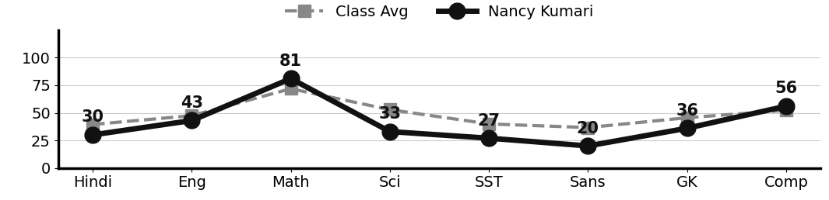
Class Teacher |  | —— Better Education ★ Brighter Future —— |  | Principal

UNIQUE CENTRAL SCHOOL
KNOWLEDGE ★ CHARACTER ★ PROGRESS
ACADEMIC SESSION : 2026 – 2027
RESULT / MARKSHEET
(P.T.1 – 40 | P.T..2 – 40 | S.A.-1 – 80 | Total – 100)

Class : II | Section : A | Roll No. : 12

Student Information  Student Name : Priya Kumari  Father’s Name : Mr. Shushil Yadav  Mother’s Name : Mrs. Puja Devi | PHOTO  (Optional) | Result Summary
  Total Marks : | 317 / 800
  Percentage (%) : | 39.62 %
  Overall Grade : | D
  Result : | PASS
  Rank : | 28

S.No. | Subject | Internal Assessment |  |  |  | Summative  Assessment I  (80 marks) | Total  (100 marks) | Grade
S.No. | Subject | P.T. I | P.T. II | Multiple Assessment | Subject Enrichment | Summative  Assessment I  (80 marks) | Total  (100 marks) | Grade
S.No. | Subject | (5 marks) | (5 marks) | (5 marks) | (5 marks) | Summative  Assessment I  (80 marks) | Total  (100 marks) | Grade
1 | Hindi | 0 | 2 | 4 | 4 | 20 | 30 | E
2 | English | 0 | 3 | 4 | 4 | 30 | 41 | C2
3 | Maths | 0 | 3 | 4 | 4 | 69 | 80 | B1
4 | Science | 0 | 1 | 4 | 4 | 26 | 35 | D
5 | Social Sc. | 2 | 2 | 4 | 4 | 19 | 31 | D
6 | Sans. / Urdu | 1 | 4 | 4 | 4 | 10 | 23 | E
7 | G.K. | 0 | 3 | 4 | 4 | 18 | 29 | E
8 | Computer | 0 | 3 | 4 | 4 | 37 | 48 | C2

CO-SCHOLASTIC AREAS |  |  |  |  |  |  | SCALE
Subject | Drawing | Music | Uniform | Sports | Discipline |  | GRADE | A1 | A2 | B1 | B2 | C1 | C2 | D | E
Grade | C | C | B | B | B |  | MARKS RANGE | 91-100 | 81-90 | 71-80 | 61-70 | 51-60 | 41-50 | 31-40 | Below 30
 |  |  |  |  |  |  | CO-SCH. AREAS | GRADE A  Outstanding |  | GRADE B  Very Good |  | GRADE C  Fair

Attendance  Working Days : 132  Present : 98  Absent : 34 | Teacher’s Remark  Priya needs to work harder and revise daily. With support at  home, improvement is possible. |  | Performance Chart (Total /100 : Student vs Class Average)  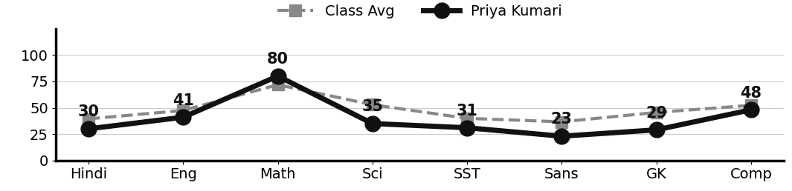
Class Teacher |  | —— Better Education ★ Brighter Future —— |  | Principal

UNIQUE CENTRAL SCHOOL
KNOWLEDGE ★ CHARACTER ★ PROGRESS
ACADEMIC SESSION : 2026 – 2027
RESULT / MARKSHEET
(P.T.1 – 40 | P.T..2 – 40 | S.A.-1 – 80 | Total – 100)

Class : II | Section : A | Roll No. : 13

Student Information  Student Name : Raushani Praveen  Father’s Name : Mr. Md. Mojahid Hussain  Mother’s Name : Mrs. Chandani Praveen | PHOTO  (Optional) | Result Summary
  Total Marks : | 341 / 800
  Percentage (%) : | 42.62 %
  Overall Grade : | C2
  Result : | PASS
  Rank : | 22

S.No. | Subject | Internal Assessment |  |  |  | Summative  Assessment I  (80 marks) | Total  (100 marks) | Grade
S.No. | Subject | P.T. I | P.T. II | Multiple Assessment | Subject Enrichment | Summative  Assessment I  (80 marks) | Total  (100 marks) | Grade
S.No. | Subject | (5 marks) | (5 marks) | (5 marks) | (5 marks) | Summative  Assessment I  (80 marks) | Total  (100 marks) | Grade
1 | Hindi | 4 | 3 | 4 | 4 | 15 | 30 | E
2 | English | 3 | 4 | 4 | 4 | 24 | 39 | D
3 | Maths | 3 | 4 | 4 | 4 | 58 | 73 | B1
4 | Science | 1 | 2 | 4 | 4 | 31 | 42 | C2
5 | Social Sc. | 2 | 3 | 4 | 4 | 18 | 31 | D
6 | Sans. / Urdu | 1 | 3 | 4 | 4 | 25 | 37 | D
7 | G.K. | 4 | 3 | 4 | 4 | 20 | 35 | D
8 | Computer | 4 | 4 | 4 | 4 | 38 | 54 | C1

CO-SCHOLASTIC AREAS |  |  |  |  |  |  | SCALE
Subject | Drawing | Music | Uniform | Sports | Discipline |  | GRADE | A1 | A2 | B1 | B2 | C1 | C2 | D | E
Grade | C | C | A | B | B |  | MARKS RANGE | 91-100 | 81-90 | 71-80 | 61-70 | 51-60 | 41-50 | 31-40 | Below 30
 |  |  |  |  |  |  | CO-SCH. AREAS | GRADE A  Outstanding |  | GRADE B  Very Good |  | GRADE C  Fair

Attendance  Working Days : 132  Present : 119  Absent : 13 | Teacher’s Remark  Raushani can do better with more attention and daily  practice. Give more time to Hindi. |  | Performance Chart (Total /100 : Student vs Class Average)  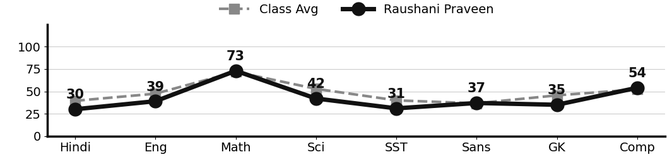
Class Teacher |  | —— Better Education ★ Brighter Future —— |  | Principal

UNIQUE CENTRAL SCHOOL
KNOWLEDGE ★ CHARACTER ★ PROGRESS
ACADEMIC SESSION : 2026 – 2027
RESULT / MARKSHEET
(P.T.1 – 40 | P.T..2 – 40 | S.A.-1 – 80 | Total – 100)

Class : II | Section : A | Roll No. : 14

Student Information  Student Name : Shivam Kumar  Father’s Name : Mr. Ranjan Kumar  Mother’s Name : Mrs. Nithu Devi | PHOTO  (Optional) | Result Summary
  Total Marks : | 328 / 700
  Percentage (%) : | 46.86 %
  Overall Grade : | C2
  Result : | PASS
  Rank : | 15

S.No. | Subject | Internal Assessment |  |  |  | Summative  Assessment I  (80 marks) | Total  (100 marks) | Grade
S.No. | Subject | P.T. I | P.T. II | Multiple Assessment | Subject Enrichment | Summative  Assessment I  (80 marks) | Total  (100 marks) | Grade
S.No. | Subject | (5 marks) | (5 marks) | (5 marks) | (5 marks) | Summative  Assessment I  (80 marks) | Total  (100 marks) | Grade
1 | Hindi | 3 | 2 |  |  | - | - | -
2 | English | 3 | 3 | 4 | 4 | 24 | 38 | D
3 | Maths | 4 | 4 | 4 | 4 | 66 | 82 | A2
4 | Science | 0 | 1 | 4 | 4 | 49 | 58 | C1
5 | Social Sc. | 2 | 1 | 4 | 4 | 21 | 32 | D
6 | Sans. / Urdu | 2 | 3 | 4 | 4 | 23 | 36 | D
7 | G.K. | 1 | 3 | 4 | 4 | 20 | 32 | D
8 | Computer | 2 | 2 | 4 | 4 | 38 | 50 | C2

CO-SCHOLASTIC AREAS |  |  |  |  |  |  | SCALE
Subject | Drawing | Music | Uniform | Sports | Discipline |  | GRADE | A1 | A2 | B1 | B2 | C1 | C2 | D | E
Grade | B | C | A | B | B |  | MARKS RANGE | 91-100 | 81-90 | 71-80 | 61-70 | 51-60 | 41-50 | 31-40 | Below 30
 |  |  |  |  |  |  | CO-SCH. AREAS | GRADE A  Outstanding |  | GRADE B  Very Good |  | GRADE C  Fair

Attendance  Working Days : 132  Present : 107  Absent : 25 | Teacher’s Remark  Shivam is making steady effort but needs more practice and  regular revision. Give more time to Social Science. |  | Performance Chart (Total /100 : Student vs Class Average)  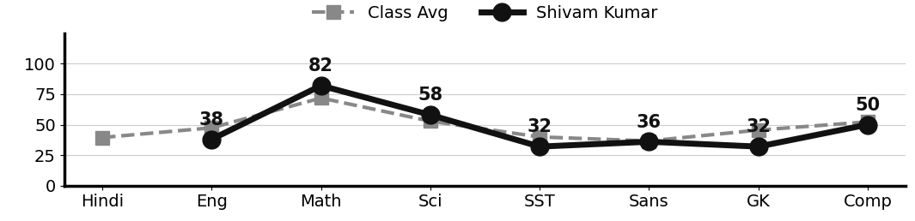
Class Teacher |  | —— Better Education ★ Brighter Future —— |  | Principal

UNIQUE CENTRAL SCHOOL
KNOWLEDGE ★ CHARACTER ★ PROGRESS
ACADEMIC SESSION : 2026 – 2027
RESULT / MARKSHEET
(P.T.1 – 40 | P.T..2 – 40 | S.A.-1 – 80 | Total – 100)

Class : II | Section : A | Roll No. : 15

Student Information  Student Name : Ayush Kumar  Father’s Name : Mr. Dharmendra Prasad  Mother’s Name : Mrs. Archana Devi | PHOTO  (Optional) | Result Summary
  Total Marks : | 319 / 800
  Percentage (%) : | 39.88 %
  Overall Grade : | D
  Result : | PASS
  Rank : | 27

S.No. | Subject | Internal Assessment |  |  |  | Summative  Assessment I  (80 marks) | Total  (100 marks) | Grade
S.No. | Subject | P.T. I | P.T. II | Multiple Assessment | Subject Enrichment | Summative  Assessment I  (80 marks) | Total  (100 marks) | Grade
S.No. | Subject | (5 marks) | (5 marks) | (5 marks) | (5 marks) | Summative  Assessment I  (80 marks) | Total  (100 marks) | Grade
1 | Hindi | 3 | 0 | 4 | 4 | 15 | 26 | E
2 | English | 1 | 0 | 4 | 4 | 32 | 41 | C2
3 | Maths | 3 | 4 | 4 | 4 | 65 | 80 | B1
4 | Science | 2 | 1 | 4 | 4 | 50 | 61 | B2
5 | Social Sc. | 1 | 2 | 4 | 4 | 26 | 37 | D
6 | Sans. / Urdu | 1 | 3 | 4 | 4 | 0 | 12 | E
7 | G.K. | 0 | 0 | 4 | 4 | 8 | 16 | E
8 | Computer | 2 | 0 | 4 | 4 | 36 | 46 | C2

CO-SCHOLASTIC AREAS |  |  |  |  |  |  | SCALE
Subject | Drawing | Music | Uniform | Sports | Discipline |  | GRADE | A1 | A2 | B1 | B2 | C1 | C2 | D | E
Grade | B | C | A | B | B |  | MARKS RANGE | 91-100 | 81-90 | 71-80 | 61-70 | 51-60 | 41-50 | 31-40 | Below 30
 |  |  |  |  |  |  | CO-SCH. AREAS | GRADE A  Outstanding |  | GRADE B  Very Good |  | GRADE C  Fair

Attendance  Working Days : 132  Present : 113  Absent : 19 | Teacher’s Remark  Ayush should study regularly and take extra guidance.  Improvement is possible with hard work. |  | Performance Chart (Total /100 : Student vs Class Average)  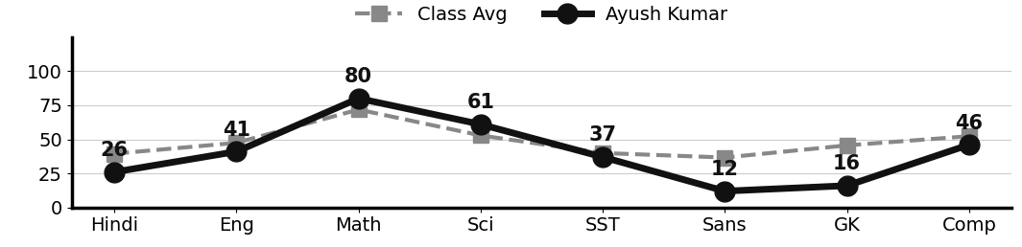
Class Teacher |  | —— Better Education ★ Brighter Future —— |  | Principal

UNIQUE CENTRAL SCHOOL
KNOWLEDGE ★ CHARACTER ★ PROGRESS
ACADEMIC SESSION : 2026 – 2027
RESULT / MARKSHEET
(P.T.1 – 40 | P.T..2 – 40 | S.A.-1 – 80 | Total – 100)

Class : II | Section : A | Roll No. : 16

Student Information  Student Name : Sneety Kumari  Father’s Name : Mr. Santosh Prasad  Mother’s Name : Mrs. Prity Devi | PHOTO  (Optional) | Result Summary
  Total Marks : | 350 / 800
  Percentage (%) : | 43.75 %
  Overall Grade : | C2
  Result : | PASS
  Rank : | 20

S.No. | Subject | Internal Assessment |  |  |  | Summative  Assessment I  (80 marks) | Total  (100 marks) | Grade
S.No. | Subject | P.T. I | P.T. II | Multiple Assessment | Subject Enrichment | Summative  Assessment I  (80 marks) | Total  (100 marks) | Grade
S.No. | Subject | (5 marks) | (5 marks) | (5 marks) | (5 marks) | Summative  Assessment I  (80 marks) | Total  (100 marks) | Grade
1 | Hindi | 3 | 2 | 4 | 4 | 10 | 23 | E
2 | English | 1 | 3 | 4 | 4 | 27 | 39 | D
3 | Maths | 4 | 3 | 4 | 4 | 69 | 84 | A2
4 | Science | 1 | 1 | 4 | 4 | 54 | 64 | B2
5 | Social Sc. | 1 | 4 | 4 | 4 | 24 | 37 | D
6 | Sans. / Urdu | 1 | 2 | 4 | 4 | 14 | 25 | E
7 | G.K. | 3 | 3 | 4 | 4 | 18 | 32 | D
8 | Computer | 4 | 3 | 4 | 4 | 31 | 46 | C2

CO-SCHOLASTIC AREAS |  |  |  |  |  |  | SCALE
Subject | Drawing | Music | Uniform | Sports | Discipline |  | GRADE | A1 | A2 | B1 | B2 | C1 | C2 | D | E
Grade | B | C | A | B | A |  | MARKS RANGE | 91-100 | 81-90 | 71-80 | 61-70 | 51-60 | 41-50 | 31-40 | Below 30
 |  |  |  |  |  |  | CO-SCH. AREAS | GRADE A  Outstanding |  | GRADE B  Very Good |  | GRADE C  Fair

Attendance  Working Days : 132  Present : 125  Absent : 7 | Teacher’s Remark  Sneety can do better with more attention and daily practice.  Give more time to Hindi. |  | Performance Chart (Total /100 : Student vs Class Average)  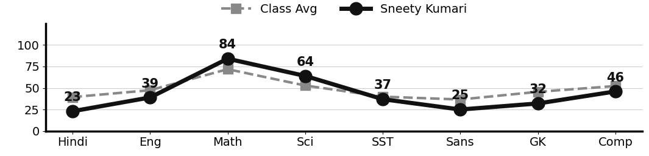
Class Teacher |  | —— Better Education ★ Brighter Future —— |  | Principal

UNIQUE CENTRAL SCHOOL
KNOWLEDGE ★ CHARACTER ★ PROGRESS
ACADEMIC SESSION : 2026 – 2027
RESULT / MARKSHEET
(P.T.1 – 40 | P.T..2 – 40 | S.A.-1 – 80 | Total – 100)

Class : II | Section : A | Roll No. : 17

Student Information  Student Name : Arush Kumar  Father’s Name : Mr. Vidyanand Kumar  Mother’s Name : Mrs. Munita Kumari | PHOTO  (Optional) | Result Summary
  Total Marks : | 336 / 800
  Percentage (%) : | 42.00 %
  Overall Grade : | C2
  Result : | PASS
  Rank : | 23

S.No. | Subject | Internal Assessment |  |  |  | Summative  Assessment I  (80 marks) | Total  (100 marks) | Grade
S.No. | Subject | P.T. I | P.T. II | Multiple Assessment | Subject Enrichment | Summative  Assessment I  (80 marks) | Total  (100 marks) | Grade
S.No. | Subject | (5 marks) | (5 marks) | (5 marks) | (5 marks) | Summative  Assessment I  (80 marks) | Total  (100 marks) | Grade
1 | Hindi | 3 | 3 | 4 | 4 | 23 | 37 | D
2 | English | 2 | 5 | 4 | 4 | 27 | 42 | C2
3 | Maths | 2 | 5 | 4 | 4 | 38 | 53 | C1
4 | Science | 2 | 4 | 4 | 4 | 40 | 54 | C1
5 | Social Sc. | 2 | 3 | 4 | 4 | 20 | 33 | D
6 | Sans. / Urdu | 2 | 2 | 4 | 4 | 26 | 38 | D
7 | G.K. | 1 | 4 | 4 | 4 | 20 | 33 | D
8 | Computer | 0 | 2 | 4 | 4 | 36 | 46 | C2

CO-SCHOLASTIC AREAS |  |  |  |  |  |  | SCALE
Subject | Drawing | Music | Uniform | Sports | Discipline |  | GRADE | A1 | A2 | B1 | B2 | C1 | C2 | D | E
Grade | C | C | A | C | B |  | MARKS RANGE | 91-100 | 81-90 | 71-80 | 61-70 | 51-60 | 41-50 | 31-40 | Below 30
 |  |  |  |  |  |  | CO-SCH. AREAS | GRADE A  Outstanding |  | GRADE B  Very Good |  | GRADE C  Fair

Attendance  Working Days : 132  Present : 121  Absent : 11 | Teacher’s Remark  Arush is making steady effort but needs more practice and  regular revision. Give more time to Social Science. |  | Performance Chart (Total /100 : Student vs Class Average)  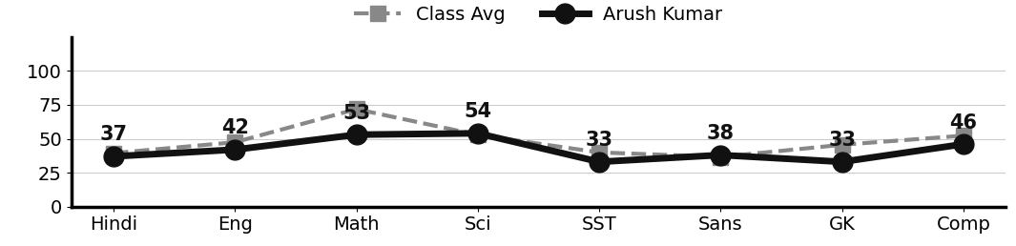
Class Teacher |  | —— Better Education ★ Brighter Future —— |  | Principal

UNIQUE CENTRAL SCHOOL
KNOWLEDGE ★ CHARACTER ★ PROGRESS
ACADEMIC SESSION : 2026 – 2027
RESULT / MARKSHEET
(P.T.1 – 40 | P.T..2 – 40 | S.A.-1 – 80 | Total – 100)

Class : II | Section : A | Roll No. : 18

Student Information  Student Name : Anjali Kumari  Father’s Name : Mr. Dasai Sah  Mother’s Name : Mrs. Anita Devi | PHOTO  (Optional) | Result Summary
  Total Marks : | 281 / 800
  Percentage (%) : | 35.12 %
  Overall Grade : | D
  Result : | PASS
  Rank : | 31

S.No. | Subject | Internal Assessment |  |  |  | Summative  Assessment I  (80 marks) | Total  (100 marks) | Grade
S.No. | Subject | P.T. I | P.T. II | Multiple Assessment | Subject Enrichment | Summative  Assessment I  (80 marks) | Total  (100 marks) | Grade
S.No. | Subject | (5 marks) | (5 marks) | (5 marks) | (5 marks) | Summative  Assessment I  (80 marks) | Total  (100 marks) | Grade
1 | Hindi | 3 | 2 | 4 | 4 | 7 | 20 | E
2 | English | 2 | 2 | 4 | 4 | 30 | 42 | C2
3 | Maths | 4 | 4 | 4 | 4 | 45 | 61 | B2
4 | Science | 2 | 2 | 4 | 4 | 24 | 36 | D
5 | Social Sc. | 2 | 2 | 4 | 4 | 20 | 32 | D
6 | Sans. / Urdu | 1 | 3 | 4 | 4 | 5 | 17 | E
7 | G.K. | 3 | 0 | 4 | 4 | 22 | 33 | D
8 | Computer | 2 | 2 | 4 | 4 | 28 | 40 | D

CO-SCHOLASTIC AREAS |  |  |  |  |  |  | SCALE
Subject | Drawing | Music | Uniform | Sports | Discipline |  | GRADE | A1 | A2 | B1 | B2 | C1 | C2 | D | E
Grade | C | C | A | C | B |  | MARKS RANGE | 91-100 | 81-90 | 71-80 | 61-70 | 51-60 | 41-50 | 31-40 | Below 30
 |  |  |  |  |  |  | CO-SCH. AREAS | GRADE A  Outstanding |  | GRADE B  Very Good |  | GRADE C  Fair

Attendance  Working Days : 132  Present : 120  Absent : 12 | Teacher’s Remark  Anjali needs to work harder and revise daily. With support at  home, improvement is possible. |  | Performance Chart (Total /100 : Student vs Class Average)  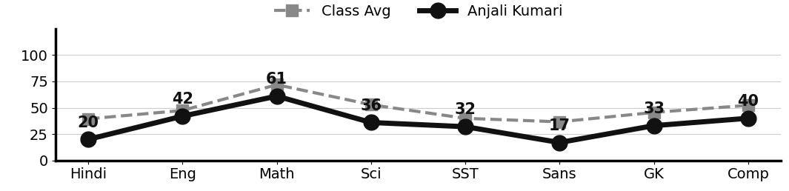
Class Teacher |  | —— Better Education ★ Brighter Future —— |  | Principal

UNIQUE CENTRAL SCHOOL
KNOWLEDGE ★ CHARACTER ★ PROGRESS
ACADEMIC SESSION : 2026 – 2027
RESULT / MARKSHEET
(P.T.1 – 40 | P.T..2 – 40 | S.A.-1 – 80 | Total – 100)

Class : II | Section : A | Roll No. : 19

Student Information  Student Name : Anupriya Rani  Father’s Name : Mr. Santosh Kumar  Mother’s Name : Mrs. Shobha Kumari | PHOTO  (Optional) | Result Summary
  Total Marks : | 387 / 800
  Percentage (%) : | 48.38 %
  Overall Grade : | C2
  Result : | PASS
  Rank : | 12

S.No. | Subject | Internal Assessment |  |  |  | Summative  Assessment I  (80 marks) | Total  (100 marks) | Grade
S.No. | Subject | P.T. I | P.T. II | Multiple Assessment | Subject Enrichment | Summative  Assessment I  (80 marks) | Total  (100 marks) | Grade
S.No. | Subject | (5 marks) | (5 marks) | (5 marks) | (5 marks) | Summative  Assessment I  (80 marks) | Total  (100 marks) | Grade
1 | Hindi | 4 | 2 | 4 | 4 | 23 | 37 | D
2 | English | 3 | 4 | 4 | 4 | 36 | 51 | C1
3 | Maths | 4 | 3 | 4 | 4 | 59 | 74 | B1
4 | Science | 2 | 3 | 4 | 4 | 24 | 37 | D
5 | Social Sc. | 2 | 1 | 4 | 4 | 24 | 35 | D
6 | Sans. / Urdu | 4 | 2 | 4 | 4 | 30 | 44 | C2
7 | G.K. | 3 | 3 | 4 | 4 | 24 | 38 | D
8 | Computer | 5 | 3 | 4 | 4 | 55 | 71 | B1

CO-SCHOLASTIC AREAS |  |  |  |  |  |  | SCALE
Subject | Drawing | Music | Uniform | Sports | Discipline |  | GRADE | A1 | A2 | B1 | B2 | C1 | C2 | D | E
Grade | C | C | B | B | B |  | MARKS RANGE | 91-100 | 81-90 | 71-80 | 61-70 | 51-60 | 41-50 | 31-40 | Below 30
 |  |  |  |  |  |  | CO-SCH. AREAS | GRADE A  Outstanding |  | GRADE B  Very Good |  | GRADE C  Fair

Attendance  Working Days : 132  Present : 97  Absent : 35 | Teacher’s Remark  Anupriya can do better with more attention and daily  practice. Give more time to Social Science. |  | Performance Chart (Total /100 : Student vs Class Average)  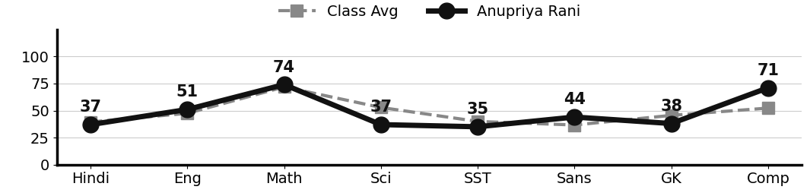
Class Teacher |  | —— Better Education ★ Brighter Future —— |  | Principal

UNIQUE CENTRAL SCHOOL
KNOWLEDGE ★ CHARACTER ★ PROGRESS
ACADEMIC SESSION : 2026 – 2027
RESULT / MARKSHEET
(P.T.1 – 40 | P.T..2 – 40 | S.A.-1 – 80 | Total – 100)

Class : II | Section : A | Roll No. : 20

Student Information  Student Name : Saurav Kumar  Father’s Name : Mr. Shushil Yadav  Mother’s Name : Mrs. Reena Devi | PHOTO  (Optional) | Result Summary
  Total Marks : | 281 / 700
  Percentage (%) : | 40.14 %
  Overall Grade : | D
  Result : | PASS
  Rank : | 26

S.No. | Subject | Internal Assessment |  |  |  | Summative  Assessment I  (80 marks) | Total  (100 marks) | Grade
S.No. | Subject | P.T. I | P.T. II | Multiple Assessment | Subject Enrichment | Summative  Assessment I  (80 marks) | Total  (100 marks) | Grade
S.No. | Subject | (5 marks) | (5 marks) | (5 marks) | (5 marks) | Summative  Assessment I  (80 marks) | Total  (100 marks) | Grade
1 | Hindi | 0 | 2 | 4 | 4 | 30 | 40 | D
2 | English | 0 | 3 | 4 | 4 | 29 | 40 | D
3 | Maths | 4 | 3 | 4 | 4 | 44 | 59 | C1
4 | Science | 1 | 4 |  |  | - | - | -
5 | Social Sc. | 2 | 2 | 4 | 4 | 10 | 22 | E
6 | Sans. / Urdu | 1 | 3 | 4 | 4 | 13 | 25 | E
7 | G.K. | 0 | 3 | 4 | 4 | 44 | 55 | C1
8 | Computer | 0 | 2 | 4 | 4 | 30 | 40 | D

CO-SCHOLASTIC AREAS |  |  |  |  |  |  | SCALE
Subject | Drawing | Music | Uniform | Sports | Discipline |  | GRADE | A1 | A2 | B1 | B2 | C1 | C2 | D | E
Grade | C | C | B | C | B |  | MARKS RANGE | 91-100 | 81-90 | 71-80 | 61-70 | 51-60 | 41-50 | 31-40 | Below 30
 |  |  |  |  |  |  | CO-SCH. AREAS | GRADE A  Outstanding |  | GRADE B  Very Good |  | GRADE C  Fair

Attendance  Working Days : 132  Present : 101  Absent : 31 | Teacher’s Remark  Saurav needs to work harder and revise daily. With support at  home, improvement is possible. |  | Performance Chart (Total /100 : Student vs Class Average)  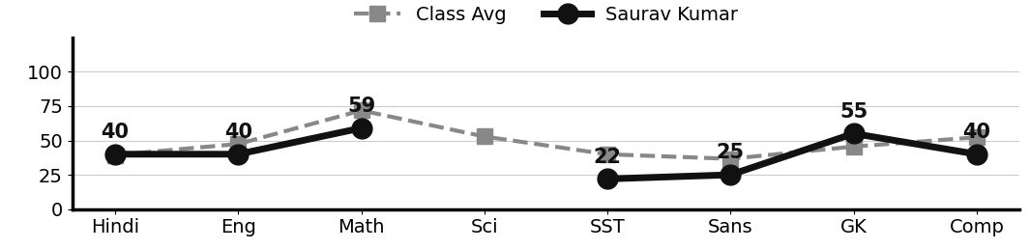
Class Teacher |  | —— Better Education ★ Brighter Future —— |  | Principal

UNIQUE CENTRAL SCHOOL
KNOWLEDGE ★ CHARACTER ★ PROGRESS
ACADEMIC SESSION : 2026 – 2027
RESULT / MARKSHEET
(P.T.1 – 40 | P.T..2 – 40 | S.A.-1 – 80 | Total – 100)

Class : II | Section : A | Roll No. : 21

Student Information  Student Name : Sunny Kumar  Father’s Name : Mr. Suraj Kumar  Mother’s Name : Mrs. Munni Devi | PHOTO  (Optional) | Result Summary
  Total Marks : | 298 / 800
  Percentage (%) : | 37.25 %
  Overall Grade : | D
  Result : | PASS
  Rank : | 30

S.No. | Subject | Internal Assessment |  |  |  | Summative  Assessment I  (80 marks) | Total  (100 marks) | Grade
S.No. | Subject | P.T. I | P.T. II | Multiple Assessment | Subject Enrichment | Summative  Assessment I  (80 marks) | Total  (100 marks) | Grade
S.No. | Subject | (5 marks) | (5 marks) | (5 marks) | (5 marks) | Summative  Assessment I  (80 marks) | Total  (100 marks) | Grade
1 | Hindi | 0 | 3 | 4 | 4 | 20 | 31 | D
2 | English | 0 | 3 | 4 | 4 | 37 | 48 | C2
3 | Maths | 0 | 2 | 4 | 4 | 37 | 47 | C2
4 | Science | 1 | 1 | 4 | 4 | 33 | 43 | C2
5 | Social Sc. | 1 | 2 | 4 | 4 | 16 | 27 | E
6 | Sans. / Urdu | 1 | 2 | 4 | 4 | 6 | 17 | E
7 | G.K. | 0 | 3 | 4 | 4 | 34 | 45 | C2
8 | Computer | 0 | 2 | 4 | 4 | 30 | 40 | D

CO-SCHOLASTIC AREAS |  |  |  |  |  |  | SCALE
Subject | Drawing | Music | Uniform | Sports | Discipline |  | GRADE | A1 | A2 | B1 | B2 | C1 | C2 | D | E
Grade | C | C | B | C | B |  | MARKS RANGE | 91-100 | 81-90 | 71-80 | 61-70 | 51-60 | 41-50 | 31-40 | Below 30
 |  |  |  |  |  |  | CO-SCH. AREAS | GRADE A  Outstanding |  | GRADE B  Very Good |  | GRADE C  Fair

Attendance  Working Days : 132  Present : 105  Absent : 27 | Teacher’s Remark  Sunny should study regularly and take extra guidance.  Improvement is possible with hard work. |  | Performance Chart (Total /100 : Student vs Class Average)  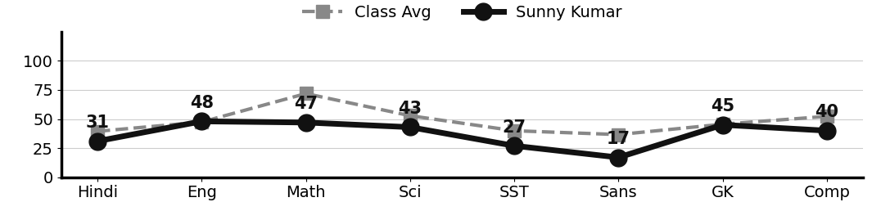
Class Teacher |  | —— Better Education ★ Brighter Future —— |  | Principal

UNIQUE CENTRAL SCHOOL
KNOWLEDGE ★ CHARACTER ★ PROGRESS
ACADEMIC SESSION : 2026 – 2027
RESULT / MARKSHEET
(P.T.1 – 40 | P.T..2 – 40 | S.A.-1 – 80 | Total – 100)

Class : II | Section : A | Roll No. : 22

Student Information  Student Name : Shiddhi Kumari  Father’s Name : Mr. Guddu Kumar  Mother’s Name : Mrs. Pooja Kumari | PHOTO  (Optional) | Result Summary
  Total Marks : | 235 / 800
  Percentage (%) : | 29.38 %
  Overall Grade : | E
  Result : | FAIL
  Rank : | 33

S.No. | Subject | Internal Assessment |  |  |  | Summative  Assessment I  (80 marks) | Total  (100 marks) | Grade
S.No. | Subject | P.T. I | P.T. II | Multiple Assessment | Subject Enrichment | Summative  Assessment I  (80 marks) | Total  (100 marks) | Grade
S.No. | Subject | (5 marks) | (5 marks) | (5 marks) | (5 marks) | Summative  Assessment I  (80 marks) | Total  (100 marks) | Grade
1 | Hindi | 2 | 0 | 4 | 4 | 15 | 25 | E
2 | English | 1 | 0 | 4 | 4 | 11 | 20 | E
3 | Maths | 3 | 0 | 4 | 4 | 43 | 54 | C1
4 | Science | 1 | 0 | 4 | 4 | 15 | 24 | E
5 | Social Sc. | 2 | 0 | 4 | 4 | 20 | 30 | E
6 | Sans. / Urdu | 1 | 2 | 4 | 4 | 2 | 13 | E
7 | G.K. | 3 | 0 | 4 | 4 | 18 | 29 | E
8 | Computer | 2 | 0 | 4 | 4 | 30 | 40 | D

CO-SCHOLASTIC AREAS |  |  |  |  |  |  | SCALE
Subject | Drawing | Music | Uniform | Sports | Discipline |  | GRADE | A1 | A2 | B1 | B2 | C1 | C2 | D | E
Grade | C | C | B | C | B |  | MARKS RANGE | 91-100 | 81-90 | 71-80 | 61-70 | 51-60 | 41-50 | 31-40 | Below 30
 |  |  |  |  |  |  | CO-SCH. AREAS | GRADE A  Outstanding |  | GRADE B  Very Good |  | GRADE C  Fair

Attendance  Working Days : 132  Present : 99  Absent : 33 | Teacher’s Remark  Shiddhi needs special attention and regular practice in all  subjects. Parents are requested to help at home. |  | Performance Chart (Total /100 : Student vs Class Average)  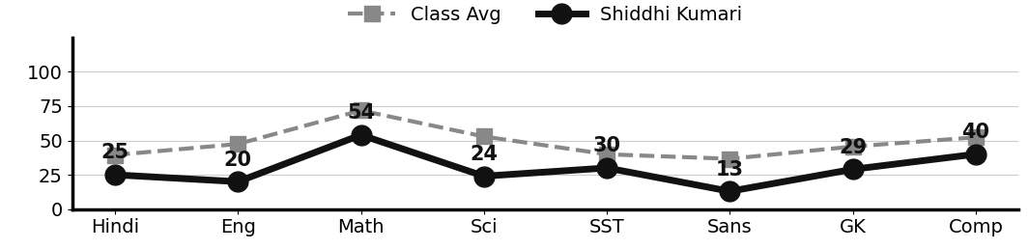
Class Teacher |  | —— Better Education ★ Brighter Future —— |  | Principal

UNIQUE CENTRAL SCHOOL
KNOWLEDGE ★ CHARACTER ★ PROGRESS
ACADEMIC SESSION : 2026 – 2027
RESULT / MARKSHEET
(P.T.1 – 40 | P.T..2 – 40 | S.A.-1 – 80 | Total – 100)

Class : II | Section : A | Roll No. : 23

Student Information  Student Name : Monu Kumar  Father’s Name : Mr. Sujeet Raj  Mother’s Name : Mrs. Neetu Devi | PHOTO  (Optional) | Result Summary
  Total Marks : | 317 / 800
  Percentage (%) : | 39.62 %
  Overall Grade : | D
  Result : | PASS
  Rank : | 28

S.No. | Subject | Internal Assessment |  |  |  | Summative  Assessment I  (80 marks) | Total  (100 marks) | Grade
S.No. | Subject | P.T. I | P.T. II | Multiple Assessment | Subject Enrichment | Summative  Assessment I  (80 marks) | Total  (100 marks) | Grade
S.No. | Subject | (5 marks) | (5 marks) | (5 marks) | (5 marks) | Summative  Assessment I  (80 marks) | Total  (100 marks) | Grade
1 | Hindi | 0 | 0 | 4 | 4 | 18 | 26 | E
2 | English | 1 | 0 | 4 | 4 | 24 | 33 | D
3 | Maths | 3 | 0 | 4 | 4 | 59 | 70 | B2
4 | Science | 1 | 0 | 4 | 4 | 44 | 53 | C1
5 | Social Sc. | 1 | 1 | 4 | 4 | 15 | 25 | E
6 | Sans. / Urdu | 0 | 1 | 4 | 4 | 5 | 14 | E
7 | G.K. | 0 | 0 | 4 | 4 | 43 | 51 | C1
8 | Computer | 2 | 0 | 4 | 4 | 35 | 45 | C2

CO-SCHOLASTIC AREAS |  |  |  |  |  |  | SCALE
Subject | Drawing | Music | Uniform | Sports | Discipline |  | GRADE | A1 | A2 | B1 | B2 | C1 | C2 | D | E
Grade | B | C | C | C | C |  | MARKS RANGE | 91-100 | 81-90 | 71-80 | 61-70 | 51-60 | 41-50 | 31-40 | Below 30
 |  |  |  |  |  |  | CO-SCH. AREAS | GRADE A  Outstanding |  | GRADE B  Very Good |  | GRADE C  Fair

Attendance  Working Days : 132  Present : 67  Absent : 65 | Teacher’s Remark  Monu should study regularly and take extra guidance.  Improvement is possible with hard work. |  | Performance Chart (Total /100 : Student vs Class Average)  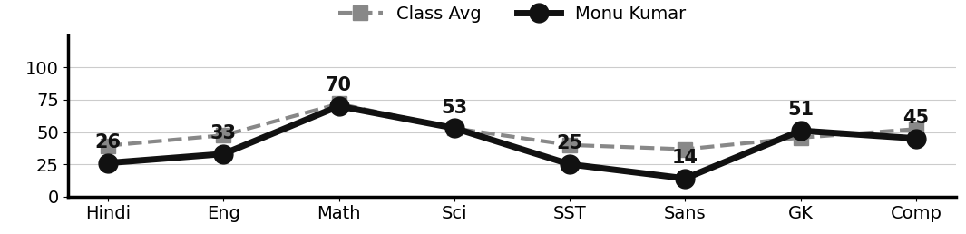
Class Teacher |  | —— Better Education ★ Brighter Future —— |  | Principal

UNIQUE CENTRAL SCHOOL
KNOWLEDGE ★ CHARACTER ★ PROGRESS
ACADEMIC SESSION : 2026 – 2027
RESULT / MARKSHEET
(P.T.1 – 40 | P.T..2 – 40 | S.A.-1 – 80 | Total – 100)

Class : II | Section : A | Roll No. : 24

Student Information  Student Name : Shubham Kumar  Father’s Name : Mr. Bhushan Kumar  Mother’s Name : Mrs. Sangita Devi | PHOTO  (Optional) | Result Summary
  Total Marks : | 248 / 800
  Percentage (%) : | 31.00 %
  Overall Grade : | D
  Result : | PASS
  Rank : | 32

S.No. | Subject | Internal Assessment |  |  |  | Summative  Assessment I  (80 marks) | Total  (100 marks) | Grade
S.No. | Subject | P.T. I | P.T. II | Multiple Assessment | Subject Enrichment | Summative  Assessment I  (80 marks) | Total  (100 marks) | Grade
S.No. | Subject | (5 marks) | (5 marks) | (5 marks) | (5 marks) | Summative  Assessment I  (80 marks) | Total  (100 marks) | Grade
1 | Hindi | 3 | 2 | 4 | 4 | 16 | 29 | E
2 | English | 1 | 2 | 4 | 4 | 21 | 32 | D
3 | Maths | 3 | 4 | 4 | 4 | 35 | 50 | C2
4 | Science | 1 | 4 | 4 | 4 | 15 | 28 | E
5 | Social Sc. | 1 | 3 | 4 | 4 | 15 | 27 | E
6 | Sans. / Urdu | 1 | 1 | 4 | 4 | 0 | 10 | E
7 | G.K. | 5 | 2 | 4 | 4 | 18 | 33 | D
8 | Computer | 2 | 2 | 4 | 4 | 27 | 39 | D

CO-SCHOLASTIC AREAS |  |  |  |  |  |  | SCALE
Subject | Drawing | Music | Uniform | Sports | Discipline |  | GRADE | A1 | A2 | B1 | B2 | C1 | C2 | D | E
Grade | C | C | A | C | B |  | MARKS RANGE | 91-100 | 81-90 | 71-80 | 61-70 | 51-60 | 41-50 | 31-40 | Below 30
 |  |  |  |  |  |  | CO-SCH. AREAS | GRADE A  Outstanding |  | GRADE B  Very Good |  | GRADE C  Fair

Attendance  Working Days : 132  Present : 122  Absent : 10 | Teacher’s Remark  Shubham needs to work harder and revise daily. With support  at home, improvement is possible. |  | Performance Chart (Total /100 : Student vs Class Average)  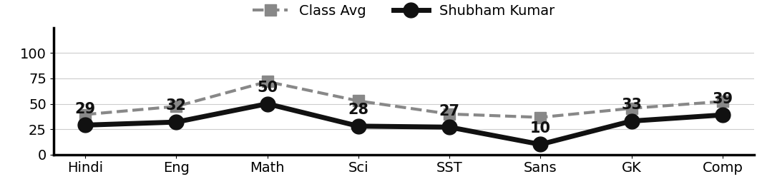
Class Teacher |  | —— Better Education ★ Brighter Future —— |  | Principal

UNIQUE CENTRAL SCHOOL
KNOWLEDGE ★ CHARACTER ★ PROGRESS
ACADEMIC SESSION : 2026 – 2027
RESULT / MARKSHEET
(P.T.1 – 40 | P.T..2 – 40 | S.A.-1 – 80 | Total – 100)

Class : II | Section : A | Roll No. : 25

Student Information  Student Name : Raunak Kumar  Father’s Name : Mr. Rahul Singh  Mother’s Name : Mrs. Rinki Devi | PHOTO  (Optional) | Result Summary
  Total Marks : | 376 / 800
  Percentage (%) : | 47.00 %
  Overall Grade : | C2
  Result : | PASS
  Rank : | 14

S.No. | Subject | Internal Assessment |  |  |  | Summative  Assessment I  (80 marks) | Total  (100 marks) | Grade
S.No. | Subject | P.T. I | P.T. II | Multiple Assessment | Subject Enrichment | Summative  Assessment I  (80 marks) | Total  (100 marks) | Grade
S.No. | Subject | (5 marks) | (5 marks) | (5 marks) | (5 marks) | Summative  Assessment I  (80 marks) | Total  (100 marks) | Grade
1 | Hindi | 3 | 0 | 4 | 4 | 31 | 42 | C2
2 | English | 3 | 0 | 4 | 4 | 21 | 32 | D
3 | Maths | 4 | 4 | 4 | 4 | 63 | 79 | B1
4 | Science | 2 | 3 | 4 | 4 | 28 | 41 | C2
5 | Social Sc. | 3 | 2 | 4 | 4 | 50 | 63 | B2
6 | Sans. / Urdu | 2 | 3 | 4 | 4 | 16 | 29 | E
7 | G.K. | 0 | 0 | 4 | 4 | 32 | 40 | D
8 | Computer | 2 | 0 | 4 | 4 | 40 | 50 | C2

CO-SCHOLASTIC AREAS |  |  |  |  |  |  | SCALE
Subject | Drawing | Music | Uniform | Sports | Discipline |  | GRADE | A1 | A2 | B1 | B2 | C1 | C2 | D | E
Grade | B | C | B | B | B |  | MARKS RANGE | 91-100 | 81-90 | 71-80 | 61-70 | 51-60 | 41-50 | 31-40 | Below 30
 |  |  |  |  |  |  | CO-SCH. AREAS | GRADE A  Outstanding |  | GRADE B  Very Good |  | GRADE C  Fair

Attendance  Working Days : 132  Present : 98  Absent : 34 | Teacher’s Remark  Raunak can do better with more attention and daily practice.  Give more time to Sanskrit/Urdu. |  | Performance Chart (Total /100 : Student vs Class Average)  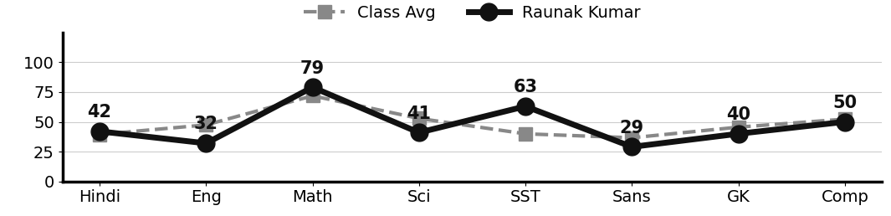
Class Teacher |  | —— Better Education ★ Brighter Future —— |  | Principal

UNIQUE CENTRAL SCHOOL
KNOWLEDGE ★ CHARACTER ★ PROGRESS
ACADEMIC SESSION : 2026 – 2027
RESULT / MARKSHEET
(P.T.1 – 40 | P.T..2 – 40 | S.A.-1 – 80 | Total – 100)

Class : II | Section : A | Roll No. : 26

Student Information  Student Name : Riya Kumari  Father’s Name : Mr. Bhottu Kumar  Mother’s Name : Mrs. Pooja Devi | PHOTO  (Optional) | Result Summary
  Total Marks :
  Percentage (%) :
  Overall Grade : | N/A
  Result :
  Rank :

S.No. | Subject | Internal Assessment |  |  |  | Summative  Assessment I  (80 marks) | Total  (100 marks) | Grade
S.No. | Subject | P.T. I | P.T. II | Multiple Assessment | Subject Enrichment | Summative  Assessment I  (80 marks) | Total  (100 marks) | Grade
S.No. | Subject | (5 marks) | (5 marks) | (5 marks) | (5 marks) | Summative  Assessment I  (80 marks) | Total  (100 marks) | Grade
1 | Hindi
2 | English
3 | Maths
4 | Science
5 | Social Sc.
6 | Sans. / Urdu
7 | G.K.
8 | Computer

CO-SCHOLASTIC AREAS |  |  |  |  |  |  | SCALE
Subject | Drawing | Music | Uniform | Sports | Discipline |  | GRADE | A1 | A2 | B1 | B2 | C1 | C2 | D | E
Grade | N/A | N/A | N/A | N/A | N/A |  | MARKS RANGE | 91-100 | 81-90 | 71-80 | 61-70 | 51-60 | 41-50 | 31-40 | Below 30
 |  |  |  |  |  |  | CO-SCH. AREAS | GRADE A  Outstanding |  | GRADE B  Very Good |  | GRADE C  Fair

Attendance  Working Days : 132  Present :  Absent : | Teacher’s Remark |  | Performance Chart (Total /100 : Student vs Class Average)  
Class Teacher |  | —— Better Education ★ Brighter Future —— |  | Principal

UNIQUE CENTRAL SCHOOL
KNOWLEDGE ★ CHARACTER ★ PROGRESS
ACADEMIC SESSION : 2026 – 2027
RESULT / MARKSHEET
(P.T.1 – 40 | P.T..2 – 40 | S.A.-1 – 80 | Total – 100)

Class : II | Section : A | Roll No. : 27

Student Information  Student Name : Manish Kumar  Father’s Name : Mr. Ravikant Roy  Mother’s Name : Mrs. Lakshmi Devi | PHOTO  (Optional) | Result Summary
  Total Marks : | 327 / 800
  Percentage (%) : | 40.88 %
  Overall Grade : | D
  Result : | PASS
  Rank : | 24

S.No. | Subject | Internal Assessment |  |  |  | Summative  Assessment I  (80 marks) | Total  (100 marks) | Grade
S.No. | Subject | P.T. I | P.T. II | Multiple Assessment | Subject Enrichment | Summative  Assessment I  (80 marks) | Total  (100 marks) | Grade
S.No. | Subject | (5 marks) | (5 marks) | (5 marks) | (5 marks) | Summative  Assessment I  (80 marks) | Total  (100 marks) | Grade
1 | Hindi | 4 | 3 | 4 | 4 | 29 | 44 | C2
2 | English | 2 | 3 | 4 | 4 | 23 | 36 | D
3 | Maths | 2 | 3 | 4 | 4 | 57 | 70 | B2
4 | Science | 1 | 1 | 4 | 4 | 30 | 40 | D
5 | Social Sc. | 1 | 1 | 4 | 4 | 20 | 30 | E
6 | Sans. / Urdu | 1 | 4 | 4 | 4 | 23 | 36 | D
7 | G.K. | 3 | 2 | 4 | 4 | 8 | 21 | E
8 | Computer | 5 | 2 | 4 | 4 | 35 | 50 | C2

CO-SCHOLASTIC AREAS |  |  |  |  |  |  | SCALE
Subject | Drawing | Music | Uniform | Sports | Discipline |  | GRADE | A1 | A2 | B1 | B2 | C1 | C2 | D | E
Grade | C | C | A | B | B |  | MARKS RANGE | 91-100 | 81-90 | 71-80 | 61-70 | 51-60 | 41-50 | 31-40 | Below 30
 |  |  |  |  |  |  | CO-SCH. AREAS | GRADE A  Outstanding |  | GRADE B  Very Good |  | GRADE C  Fair

Attendance  Working Days : 132  Present : 112  Absent : 20 | Teacher’s Remark  Manish should study regularly and take extra guidance.  Improvement is possible with hard work. |  | Performance Chart (Total /100 : Student vs Class Average)  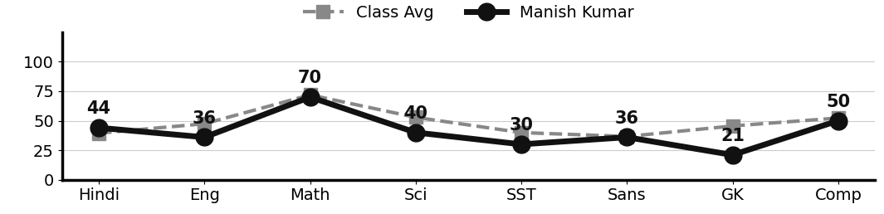
Class Teacher |  | —— Better Education ★ Brighter Future —— |  | Principal

UNIQUE CENTRAL SCHOOL
KNOWLEDGE ★ CHARACTER ★ PROGRESS
ACADEMIC SESSION : 2026 – 2027
RESULT / MARKSHEET
(P.T.1 – 40 | P.T..2 – 40 | S.A.-1 – 80 | Total – 100)

Class : II | Section : A | Roll No. : 28

Student Information  Student Name : Pushkar Anand  Father’s Name : Mr. Pankaj Kumar  Mother’s Name : Mrs. Chandani Kumari | PHOTO  (Optional) | Result Summary
  Total Marks : | 409 / 800
  Percentage (%) : | 51.12 %
  Overall Grade : | C1
  Result : | PASS
  Rank : | 10

S.No. | Subject | Internal Assessment |  |  |  | Summative  Assessment I  (80 marks) | Total  (100 marks) | Grade
S.No. | Subject | P.T. I | P.T. II | Multiple Assessment | Subject Enrichment | Summative  Assessment I  (80 marks) | Total  (100 marks) | Grade
S.No. | Subject | (5 marks) | (5 marks) | (5 marks) | (5 marks) | Summative  Assessment I  (80 marks) | Total  (100 marks) | Grade
1 | Hindi | 3 | 3 | 4 | 4 | 30 | 44 | C2
2 | English | 1 | 0 | 4 | 4 | 38 | 47 | C2
3 | Maths | 2 | 4 | 4 | 4 | 42 | 56 | C1
4 | Science | 1 | 3 | 4 | 4 | 25 | 37 | D
5 | Social Sc. | 1 | 2 | 4 | 4 | 18 | 29 | E
6 | Sans. / Urdu | 2 | 4 | 4 | 4 | 33 | 47 | C2
7 | G.K. | 0 | 0 | 4 | 4 | 64 | 72 | B1
8 | Computer | 2 | 2 | 4 | 4 | 65 | 77 | B1

CO-SCHOLASTIC AREAS |  |  |  |  |  |  | SCALE
Subject | Drawing | Music | Uniform | Sports | Discipline |  | GRADE | A1 | A2 | B1 | B2 | C1 | C2 | D | E
Grade | C | C | A | B | A |  | MARKS RANGE | 91-100 | 81-90 | 71-80 | 61-70 | 51-60 | 41-50 | 31-40 | Below 30
 |  |  |  |  |  |  | CO-SCH. AREAS | GRADE A  Outstanding |  | GRADE B  Very Good |  | GRADE C  Fair

Attendance  Working Days : 132  Present : 119  Absent : 13 | Teacher’s Remark  Good effort by Pushkar. Needs regular practice to reach a  higher level. Give more time to Social Science. |  | Performance Chart (Total /100 : Student vs Class Average)  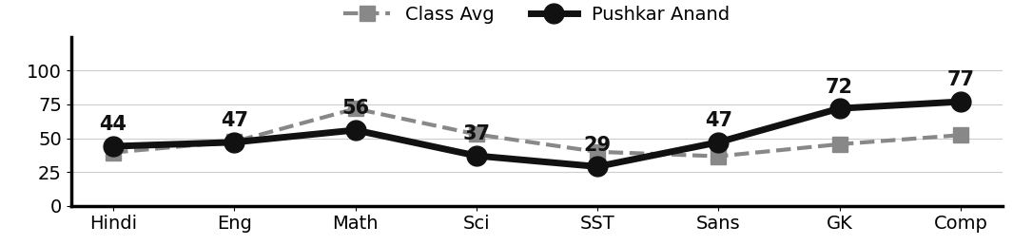
Class Teacher |  | —— Better Education ★ Brighter Future —— |  | Principal

UNIQUE CENTRAL SCHOOL
KNOWLEDGE ★ CHARACTER ★ PROGRESS
ACADEMIC SESSION : 2026 – 2027
RESULT / MARKSHEET
(P.T.1 – 40 | P.T..2 – 40 | S.A.-1 – 80 | Total – 100)

Class : II | Section : A | Roll No. : 29

Student Information  Student Name : Shashi Kumar  Father’s Name : Mr. Raju Kumar  Mother’s Name : Mrs. Reshmi Devi | PHOTO  (Optional) | Result Summary
  Total Marks : | 362 / 800
  Percentage (%) : | 45.25 %
  Overall Grade : | C2
  Result : | PASS
  Rank : | 18

S.No. | Subject | Internal Assessment |  |  |  | Summative  Assessment I  (80 marks) | Total  (100 marks) | Grade
S.No. | Subject | P.T. I | P.T. II | Multiple Assessment | Subject Enrichment | Summative  Assessment I  (80 marks) | Total  (100 marks) | Grade
S.No. | Subject | (5 marks) | (5 marks) | (5 marks) | (5 marks) | Summative  Assessment I  (80 marks) | Total  (100 marks) | Grade
1 | Hindi | 4 | 3 | 4 | 4 | 24 | 39 | D
2 | English | 2 | 3 | 4 | 4 | 31 | 44 | C2
3 | Maths | 5 | 4 | 4 | 4 | 59 | 76 | B1
4 | Science | 1 | 4 | 4 | 4 | 43 | 56 | C1
5 | Social Sc. | 2 | 2 | 4 | 4 | 25 | 37 | D
6 | Sans. / Urdu | 3 | 3 | 4 | 4 | 25 | 39 | D
7 | G.K. | 1 | 2 | 4 | 4 | 20 | 31 | D
8 | Computer | 4 | 4 | 4 | 4 | 24 | 40 | D

CO-SCHOLASTIC AREAS |  |  |  |  |  |  | SCALE
Subject | Drawing | Music | Uniform | Sports | Discipline |  | GRADE | A1 | A2 | B1 | B2 | C1 | C2 | D | E
Grade | B | C | A | C | B |  | MARKS RANGE | 91-100 | 81-90 | 71-80 | 61-70 | 51-60 | 41-50 | 31-40 | Below 30
 |  |  |  |  |  |  | CO-SCH. AREAS | GRADE A  Outstanding |  | GRADE B  Very Good |  | GRADE C  Fair

Attendance  Working Days : 132  Present : 120  Absent : 12 | Teacher’s Remark  Shashi is making steady effort but needs more practice and  regular revision. Give more time to G.K.. |  | Performance Chart (Total /100 : Student vs Class Average)  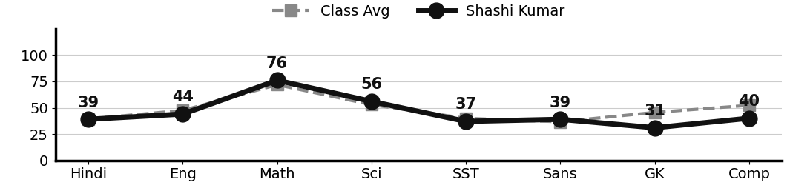
Class Teacher |  | —— Better Education ★ Brighter Future —— |  | Principal

UNIQUE CENTRAL SCHOOL
KNOWLEDGE ★ CHARACTER ★ PROGRESS
ACADEMIC SESSION : 2026 – 2027
RESULT / MARKSHEET
(P.T.1 – 40 | P.T..2 – 40 | S.A.-1 – 80 | Total – 100)

Class : II | Section : A | Roll No. : 30

Student Information  Student Name : Aryan Raj  Father’s Name : Mr. Jitendra Kumar  Mother’s Name : Mrs. Kusum Devi | PHOTO  (Optional) | Result Summary
  Total Marks : | 487 / 800
  Percentage (%) : | 60.88 %
  Overall Grade : | C1
  Result : | PASS
  Rank : | 7

S.No. | Subject | Internal Assessment |  |  |  | Summative  Assessment I  (80 marks) | Total  (100 marks) | Grade
S.No. | Subject | P.T. I | P.T. II | Multiple Assessment | Subject Enrichment | Summative  Assessment I  (80 marks) | Total  (100 marks) | Grade
S.No. | Subject | (5 marks) | (5 marks) | (5 marks) | (5 marks) | Summative  Assessment I  (80 marks) | Total  (100 marks) | Grade
1 | Hindi | 4 | 3 | 5 | 5 | 23 | 40 | D
2 | English | 3 | 4 | 5 | 5 | 65 | 82 | A2
3 | Maths | 3 | 4 | 5 | 5 | 58 | 75 | B1
4 | Science | 1 | 1 | 5 | 5 | 60 | 72 | B1
5 | Social Sc. | 2 | 3 | 5 | 5 | 51 | 66 | B2
6 | Sans. / Urdu | 3 | 0 | 5 | 5 | 19 | 32 | D
7 | G.K. | 5 | 0 | 5 | 5 | 56 | 71 | B1
8 | Computer | 2 | 0 | 5 | 5 | 37 | 49 | C2

CO-SCHOLASTIC AREAS |  |  |  |  |  |  | SCALE
Subject | Drawing | Music | Uniform | Sports | Discipline |  | GRADE | A1 | A2 | B1 | B2 | C1 | C2 | D | E
Grade | B | C | B | B | B |  | MARKS RANGE | 91-100 | 81-90 | 71-80 | 61-70 | 51-60 | 41-50 | 31-40 | Below 30
 |  |  |  |  |  |  | CO-SCH. AREAS | GRADE A  Outstanding |  | GRADE B  Very Good |  | GRADE C  Fair

Attendance  Working Days : 132  Present : 102  Absent : 30 | Teacher’s Remark  Aryan is sincere and doing well. More effort will bring  further improvement. Give more time to Sanskrit/Urdu. |  | Performance Chart (Total /100 : Student vs Class Average)  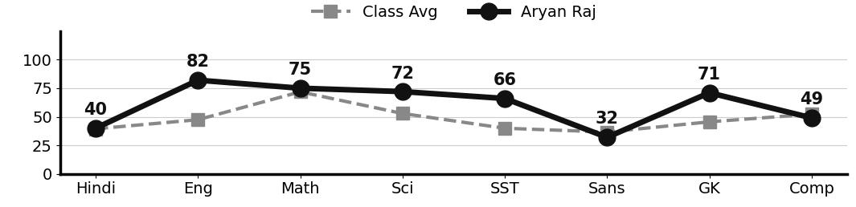
Class Teacher |  | —— Better Education ★ Brighter Future —— |  | Principal

UNIQUE CENTRAL SCHOOL
KNOWLEDGE ★ CHARACTER ★ PROGRESS
ACADEMIC SESSION : 2026 – 2027
RESULT / MARKSHEET
(P.T.1 – 40 | P.T..2 – 40 | S.A.-1 – 80 | Total – 100)

Class : II | Section : A | Roll No. : 31

Student Information  Student Name : Riya Kumari  Father’s Name : Mr. Bhotu Prasad  Mother’s Name : Mrs. Puja Devi | PHOTO  (Optional) | Result Summary
  Total Marks : | 372 / 800
  Percentage (%) : | 46.50 %
  Overall Grade : | C2
  Result : | PASS
  Rank : | 17

S.No. | Subject | Internal Assessment |  |  |  | Summative  Assessment I  (80 marks) | Total  (100 marks) | Grade
S.No. | Subject | P.T. I | P.T. II | Multiple Assessment | Subject Enrichment | Summative  Assessment I  (80 marks) | Total  (100 marks) | Grade
S.No. | Subject | (5 marks) | (5 marks) | (5 marks) | (5 marks) | Summative  Assessment I  (80 marks) | Total  (100 marks) | Grade
1 | Hindi | 4 | 0 | 4 | 4 | 31 | 43 | C2
2 | English | 4 | 0 | 4 | 4 | 9 | 21 | E
3 | Maths | 4 | 0 | 4 | 4 | 74 | 86 | A2
4 | Science | 2 | 3 | 4 | 4 | 24 | 37 | D
5 | Social Sc. | 2 | 2 | 4 | 4 | 42 | 54 | C1
6 | Sans. / Urdu | 3 | 4 | 4 | 4 | 25 | 40 | D
7 | G.K. | 4 | 0 | 4 | 4 | 30 | 42 | C2
8 | Computer | 4 | 3 | 4 | 4 | 34 | 49 | C2

CO-SCHOLASTIC AREAS |  |  |  |  |  |  | SCALE
Subject | Drawing | Music | Uniform | Sports | Discipline |  | GRADE | A1 | A2 | B1 | B2 | C1 | C2 | D | E
Grade | B | C | A | B | A |  | MARKS RANGE | 91-100 | 81-90 | 71-80 | 61-70 | 51-60 | 41-50 | 31-40 | Below 30
 |  |  |  |  |  |  | CO-SCH. AREAS | GRADE A  Outstanding |  | GRADE B  Very Good |  | GRADE C  Fair

Attendance  Working Days : 132  Present : 124  Absent : 8 | Teacher’s Remark  Riya can do better with more attention and daily practice.  Give more time to English. |  | Performance Chart (Total /100 : Student vs Class Average)  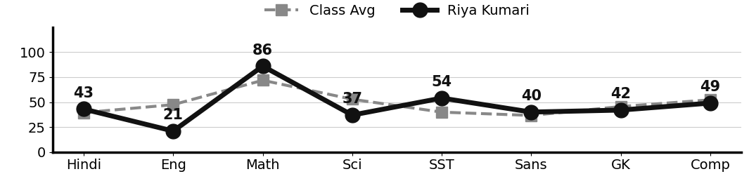
Class Teacher |  | —— Better Education ★ Brighter Future —— |  | Principal

UNIQUE CENTRAL SCHOOL
KNOWLEDGE ★ CHARACTER ★ PROGRESS
ACADEMIC SESSION : 2026 – 2027
RESULT / MARKSHEET
(P.T.1 – 40 | P.T..2 – 40 | S.A.-1 – 80 | Total – 100)

Class : II | Section : A | Roll No. : 32

Student Information  Student Name : Ravi Kumar  Father’s Name : Mr. Vinay Yadav  Mother’s Name : Mrs. Kaushlya Devi | PHOTO  (Optional) | Result Summary
  Total Marks :
  Percentage (%) :
  Overall Grade : | N/A
  Result :
  Rank :

S.No. | Subject | Internal Assessment |  |  |  | Summative  Assessment I  (80 marks) | Total  (100 marks) | Grade
S.No. | Subject | P.T. I | P.T. II | Multiple Assessment | Subject Enrichment | Summative  Assessment I  (80 marks) | Total  (100 marks) | Grade
S.No. | Subject | (5 marks) | (5 marks) | (5 marks) | (5 marks) | Summative  Assessment I  (80 marks) | Total  (100 marks) | Grade
1 | Hindi
2 | English
3 | Maths
4 | Science
5 | Social Sc.
6 | Sans. / Urdu
7 | G.K.
8 | Computer

CO-SCHOLASTIC AREAS |  |  |  |  |  |  | SCALE
Subject | Drawing | Music | Uniform | Sports | Discipline |  | GRADE | A1 | A2 | B1 | B2 | C1 | C2 | D | E
Grade | N/A | N/A | N/A | N/A | N/A |  | MARKS RANGE | 91-100 | 81-90 | 71-80 | 61-70 | 51-60 | 41-50 | 31-40 | Below 30
 |  |  |  |  |  |  | CO-SCH. AREAS | GRADE A  Outstanding |  | GRADE B  Very Good |  | GRADE C  Fair

Attendance  Working Days : 132  Present :  Absent : | Teacher’s Remark |  | Performance Chart (Total /100 : Student vs Class Average)
Class Teacher |  | —— Better Education ★ Brighter Future —— |  | Principal

UNIQUE CENTRAL SCHOOL
KNOWLEDGE ★ CHARACTER ★ PROGRESS
ACADEMIC SESSION : 2026 – 2027
RESULT / MARKSHEET
(P.T.1 – 40 | P.T..2 – 40 | S.A.-1 – 80 | Total – 100)

Class : II | Section : A | Roll No. : 33

Student Information  Student Name : Radhika Kumari  Father’s Name : Mr. Dasai Sah  Mother’s Name : Mrs. Anita Devi | PHOTO  (Optional) | Result Summary
  Total Marks : | 354 / 800
  Percentage (%) : | 44.25 %
  Overall Grade : | C2
  Result : | PASS
  Rank : | 19

S.No. | Subject | Internal Assessment |  |  |  | Summative  Assessment I  (80 marks) | Total  (100 marks) | Grade
S.No. | Subject | P.T. I | P.T. II | Multiple Assessment | Subject Enrichment | Summative  Assessment I  (80 marks) | Total  (100 marks) | Grade
S.No. | Subject | (5 marks) | (5 marks) | (5 marks) | (5 marks) | Summative  Assessment I  (80 marks) | Total  (100 marks) | Grade
1 | Hindi | 0 | 4 | 4 | 4 | 37 | 49 | C2
2 | English | 3 | 3 | 4 | 4 | 30 | 44 | C2
3 | Maths | 3 | 4 | 4 | 4 | 43 | 58 | C1
4 | Science | 1 | 2 | 4 | 4 | 37 | 48 | C2
5 | Social Sc. | 2 | 1 | 4 | 4 | 26 | 37 | D
6 | Sans. / Urdu | 3 | 3 | 4 | 4 | 28 | 42 | C2
7 | G.K. | 3 | 3 | 4 | 4 | 22 | 36 | D
8 | Computer | 2 | 2 | 4 | 4 | 28 | 40 | D

CO-SCHOLASTIC AREAS |  |  |  |  |  |  | SCALE
Subject | Drawing | Music | Uniform | Sports | Discipline |  | GRADE | A1 | A2 | B1 | B2 | C1 | C2 | D | E
Grade | C | C | A | C | B |  | MARKS RANGE | 91-100 | 81-90 | 71-80 | 61-70 | 51-60 | 41-50 | 31-40 | Below 30
 |  |  |  |  |  |  | CO-SCH. AREAS | GRADE A  Outstanding |  | GRADE B  Very Good |  | GRADE C  Fair

Attendance  Working Days : 132  Present : 117  Absent : 15 | Teacher’s Remark  Radhika has the ability to improve with regular study and  hard work. Give more time to G.K.. |  | Performance Chart (Total /100 : Student vs Class Average)  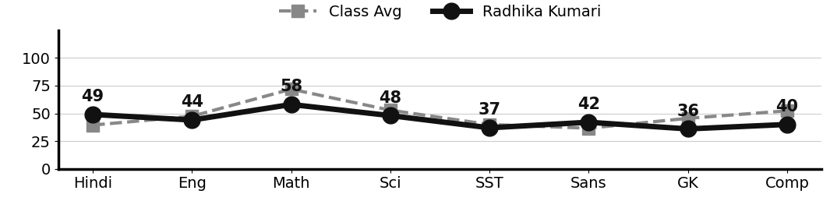
Class Teacher |  | —— Better Education ★ Brighter Future —— |  | Principal

UNIQUE CENTRAL SCHOOL
KNOWLEDGE ★ CHARACTER ★ PROGRESS
ACADEMIC SESSION : 2026 – 2027
RESULT / MARKSHEET
(P.T.1 – 40 | P.T..2 – 40 | S.A.-1 – 80 | Total – 100)

Class : II | Section : A | Roll No. : 34

Student Information  Student Name : Krishna Kumar  Father’s Name : Mr. Raj Kumar Thakur  Mother’s Name : Mrs. Umi Kumari | PHOTO  (Optional) | Result Summary
  Total Marks : | 563 / 800
  Percentage (%) : | 70.38 %
  Overall Grade : | B2
  Result : | PASS
  Rank : | 3

S.No. | Subject | Internal Assessment |  |  |  | Summative  Assessment I  (80 marks) | Total  (100 marks) | Grade
S.No. | Subject | P.T. I | P.T. II | Multiple Assessment | Subject Enrichment | Summative  Assessment I  (80 marks) | Total  (100 marks) | Grade
S.No. | Subject | (5 marks) | (5 marks) | (5 marks) | (5 marks) | Summative  Assessment I  (80 marks) | Total  (100 marks) | Grade
1 | Hindi | 4 | 3 | 5 | 5 | 45 | 62 | B2
2 | English | 2 | 4 | 5 | 5 | 60 | 76 | B1
3 | Maths | 5 | 3 | 5 | 5 | 70 | 88 | A2
4 | Science | 1 | 0 | 5 | 5 | 60 | 71 | B1
5 | Social Sc. | 1 | 0 | 5 | 5 | 45 | 56 | C1
6 | Sans. / Urdu | 2 | 0 | 5 | 5 | 66 | 78 | B1
7 | G.K. | 3 | 0 | 5 | 5 | 64 | 77 | B1
8 | Computer | 3 | 0 | 5 | 5 | 42 | 55 | C1

CO-SCHOLASTIC AREAS |  |  |  |  |  |  | SCALE
Subject | Drawing | Music | Uniform | Sports | Discipline |  | GRADE | A1 | A2 | B1 | B2 | C1 | C2 | D | E
Grade | B | B | A | B | A |  | MARKS RANGE | 91-100 | 81-90 | 71-80 | 61-70 | 51-60 | 41-50 | 31-40 | Below 30
 |  |  |  |  |  |  | CO-SCH. AREAS | GRADE A  Outstanding |  | GRADE B  Very Good |  | GRADE C  Fair

Attendance  Working Days : 132  Present : 115  Absent : 17 | Teacher’s Remark  Krishna is sincere and doing well. More effort will bring  further improvement. Give more time to Computer. |  | Performance Chart (Total /100 : Student vs Class Average)  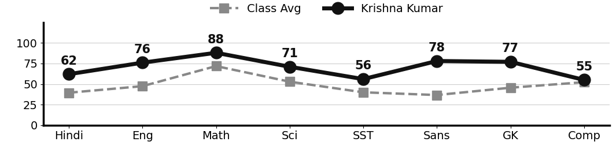
Class Teacher |  | —— Better Education ★ Brighter Future —— |  | Principal

UNIQUE CENTRAL SCHOOL
KNOWLEDGE ★ CHARACTER ★ PROGRESS
ACADEMIC SESSION : 2026 – 2027
RESULT / MARKSHEET
(P.T.1 – 40 | P.T..2 – 40 | S.A.-1 – 80 | Total – 100)

Class : II | Section : A | Roll No. : 35

Student Information  Student Name : Suraj Kumar  Father’s Name : Mr. Ravindra Prasad  Mother’s Name : Mrs. Raj Kumari | PHOTO  (Optional) | Result Summary
  Total Marks : | 433 / 800
  Percentage (%) : | 54.12 %
  Overall Grade : | C1
  Result : | PASS
  Rank : | 8

S.No. | Subject | Internal Assessment |  |  |  | Summative  Assessment I  (80 marks) | Total  (100 marks) | Grade
S.No. | Subject | P.T. I | P.T. II | Multiple Assessment | Subject Enrichment | Summative  Assessment I  (80 marks) | Total  (100 marks) | Grade
S.No. | Subject | (5 marks) | (5 marks) | (5 marks) | (5 marks) | Summative  Assessment I  (80 marks) | Total  (100 marks) | Grade
1 | Hindi | 4 | 0 | 4 | 4 | 32 | 44 | C2
2 | English | 1 | 0 | 4 | 4 | 57 | 66 | B2
3 | Maths | 5 | 0 | 4 | 4 | 52 | 65 | B2
4 | Science | 2 | 0 | 4 | 4 | 51 | 61 | B2
5 | Social Sc. | 2 | 0 | 4 | 4 | 23 | 33 | D
6 | Sans. / Urdu | 1 | 0 | 4 | 4 | 69 | 78 | B1
7 | G.K. | 0 | 0 | 4 | 4 | 26 | 34 | D
8 | Computer | 2 | 0 | 4 | 4 | 42 | 52 | C1

CO-SCHOLASTIC AREAS |  |  |  |  |  |  | SCALE
Subject | Drawing | Music | Uniform | Sports | Discipline |  | GRADE | A1 | A2 | B1 | B2 | C1 | C2 | D | E
Grade | B | B | A | C | A |  | MARKS RANGE | 91-100 | 81-90 | 71-80 | 61-70 | 51-60 | 41-50 | 31-40 | Below 30
 |  |  |  |  |  |  | CO-SCH. AREAS | GRADE A  Outstanding |  | GRADE B  Very Good |  | GRADE C  Fair

Attendance  Working Days : 132  Present : 121  Absent : 11 | Teacher’s Remark  Suraj has the ability to improve with regular study and hard  work. Give more time to Social Science. |  | Performance Chart (Total /100 : Student vs Class Average)  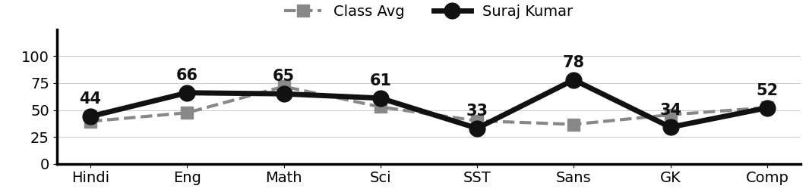
Class Teacher |  | —— Better Education ★ Brighter Future —— |  | Principal

